le uinuiai ruuiiuduuii ui mlua-^i i iiilui iiduuiidi Mbbuuduun ui uuuuMLy i i uiebbiuiiau

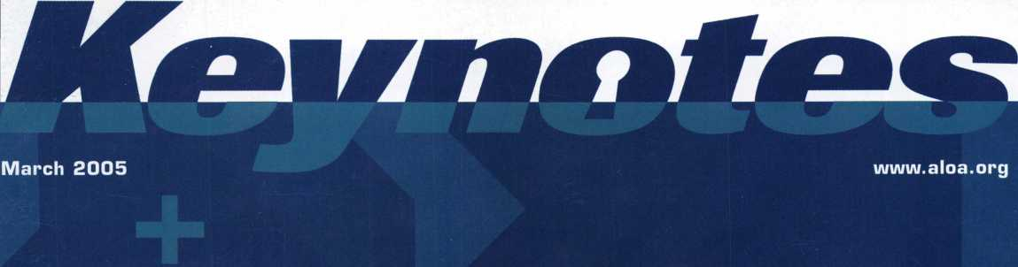

+

v

<

o*

PLUS!

**Nuns hauing fun iiiith  
Electronic Recess Control,  
Greg Perrg busts  
a 6120 lock, Rn opinion  
on Locksmith Licensing,  
Meet the 2004  
R.L.O.R. winner,**

**Bank Equipment, Super Picks and MORE!**



**Transponder  
Security  
Breached? p. 10**



Breck H. Camp Cml PO Box 47070 Atlanta GA 30362-0070

**1**11**11**1**11** **11**11**11**1111**1**1**111**11 ■ **11**111**1**111**111**111**1**

.lllnml.ll



OUR STAND

IT’S YOUR TRANSPORTATION, OFFICE,

AND LUNCHROOM.

YOUR INSURANCE COMPANY SHOULD BE

**JUST AS VERSATILE.**

Get commercial vehicle protection from Allstate.



You’re in good hands.

LOCKSMITHS

products for your small business, including commercial auto insurance. All designed to help keep your busi­ness rolling along. Are you in Good Hands®?

We know just how important your vehicle is to your business and the many roles it plays. That's why your local Allstate agent offers a wide range of insurance

1-800-859-0247

**CALL NOW TO LOCATE YOUR NEARBY ALLSTATE AGENT.**

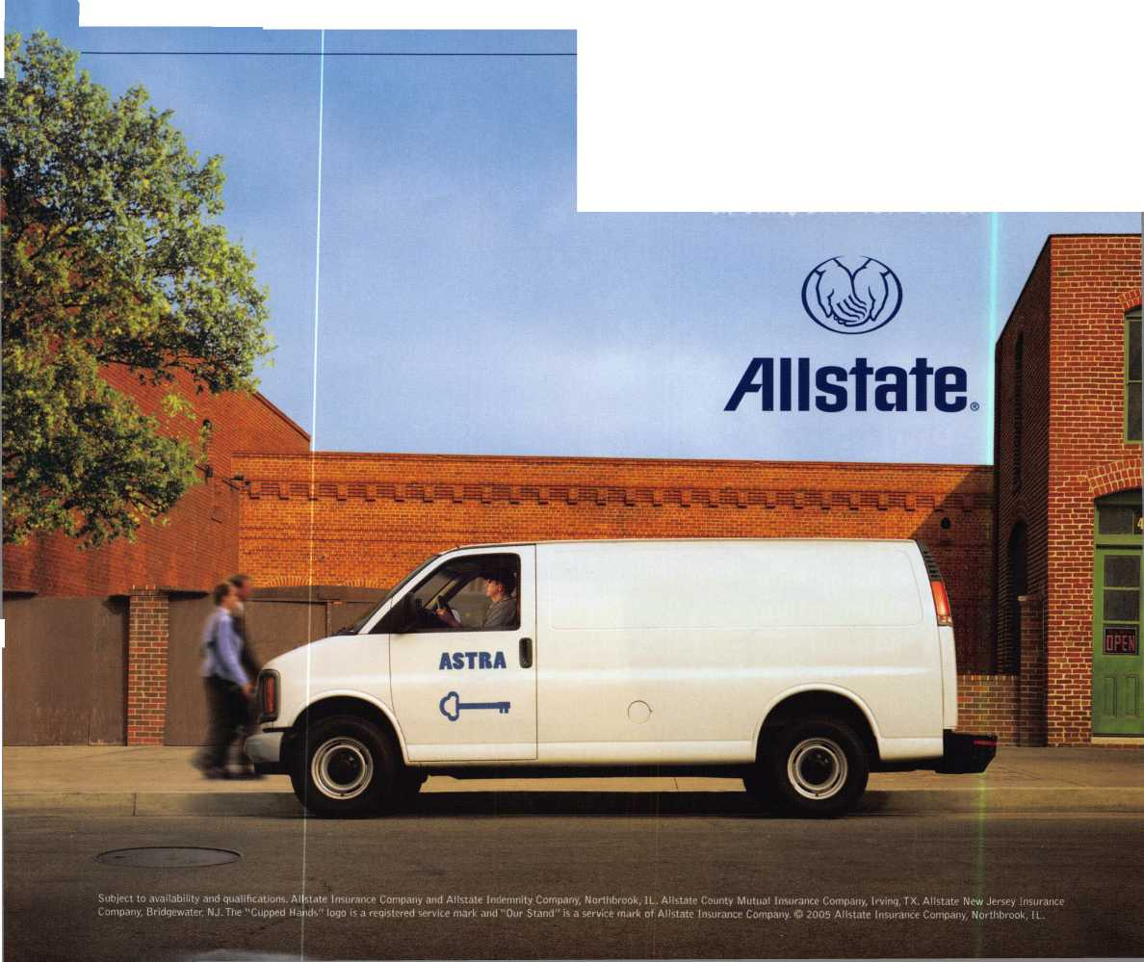

Get What's

Coming To You

ALOA continues to prouide you with this and other great benefits and services!

information in a hurry?

AlOA’s Fax On

call 310-575-5074 and receive:

ALOA Index of Documents Becoming a Locksmith (Ipg)

Locksmith Career Summary (3pg) Locksmith School List (2pg)

ACE Class Schedule (8pg) Certification lhformation(3pg)

PRP Category List (Ipg)

ALOA Membership Application(2pg) ALOA List of Benefits (Ipg) Scholarship Application Form (Ipg) ALOA Video Library Order Form (Ipg) ALOA Membership Items Order Form (Ipg)

Safe & Vault Technicians Association Member Application/Subscription Form (2pg)

ALOA Chapter Roster (3pg)

Legislative Action Network (2pg) Legislative Action Network Newsletters (Ipg)

Various State Laws (lOpg)

Industry Position Pager (Ipg)

Current Legislative Action Network Newsletters (Ipg)

Board of Directors Nomination Form (2pg)

ALOA Convention Registration ALOA Board Expense Reimbursement & Request Form

Gall Today!

310-575-5014

The next best thing to having the combination.

BETTER

THAN

EVER.

Available 7/22/05  
At ALOA  
Rosemont, IL

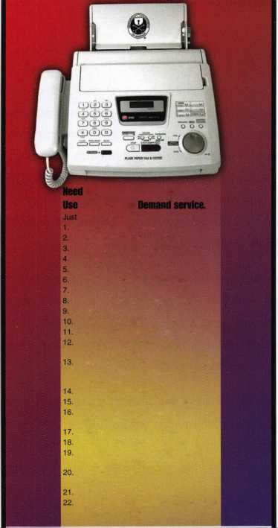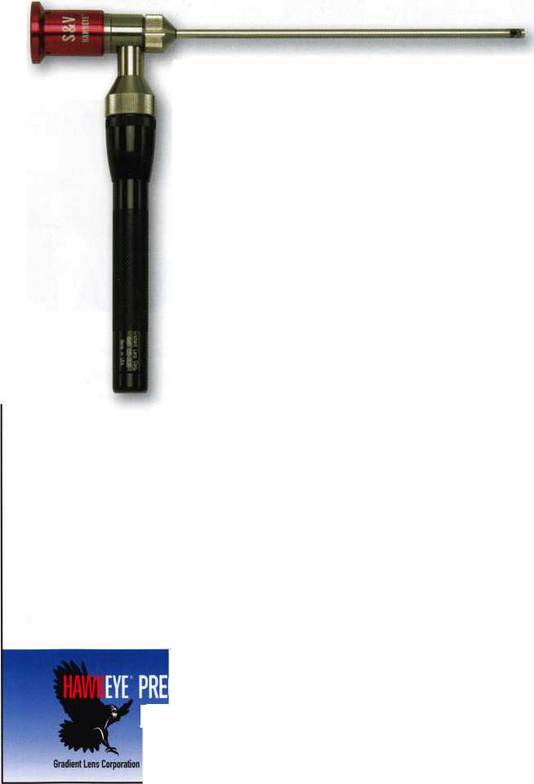

presidential

viewpoint

Important

Notice

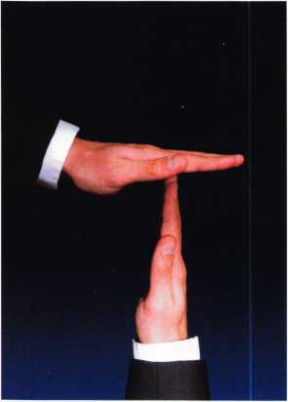

The Headquarters of the Associated Locksmiths of America will be relo­cating to a new office building some time early this year. During the time of the move, some ALOA services will be temporarily unavailable. These services include, but ar not limited to, the following:

* Incoming Calls
* Database Inquiries
* Staff Support for the Web and all other departments

It is suggested that all ALOA and SAVTA members make note of this change. (This ad will be ammended when the actual move dates are confirmed.)

The ALOA staff is looking forward to the new location and the opportunity to provide you with improved mem­ber services during 2005. Watch the latest news section at [www.aloa.org](http://www.aloa.org) for more information.

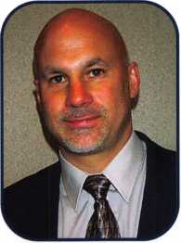

Dear Members,

The issue of automotive manufacturers releasing key and pin  
codes to locksmiths continues to be a primary concern of many  
in our industry and is a hot topic on internet locksmith sites.  
The decision by General Motors to change its policies con-  
cerning the releasing of key codes has sent a shock wave  
through the automotive locksmith sector and is a setback  
toward our efforts of convincing other automotive manufac-  
turers to give us this information.

GM has long been a "locksmith friendly" manufacturer and maintained a comprehensive data­base of key information. That information was readily available to locksmiths who are part of GM's roadside network or have good working relationships with GM dealerships. GM recent­ly contracted Cross Country to dispatch its roadside assistance calls and, at the same time, severe­ly tightened its policies concerning the release of key information.

GM will now require the owner of a vehicle in need of a key to physically come into the deal-  
ership with ID and proof of ownership before the key information will be released. As we all  
know, this is not practical for motorists who are stranded without a key, especially when most  
of these needs occur when a dealership is closed! And from my experience, the dealerships  
are adhering to the directive from GM.

ALOA continues to support the Motor Vehicle Owners Right to Repair Act through its participa-  
tion in the National Automotive Service Task Force. In the meantime, our executive director is explor-  
ing the possibility of taking legal action against automotive manufacturers in order for ALOA mem-  
bers to be able to receive codes. Our strength is in the quality and professionalism of our mem-  
bership. This, again, is another reason why the board of directors is striving to maintain that qual-  
ity of membership through tougher standards...so that we can market it to the manufacturers.

The Spring meeting of your board of directors will be held in conjunction with the Colorado  
Security Education Conference in Denver. The board meeting dates are April 29 and 30. This  
should be a good educational opportunity and I encourage those in the Rocky Mountain area  
to attend. Please feel free to sit in on the board meeting as well. Also, there are several pro-  
posed by-laws changes that will begin appearing in Keynotes. I encourage you to read these  
thoroughly and exercise your right to vote! The board has worked diligently to bring about pos-  
itive changes and I urge you to vote these changes in!

Sincerely,

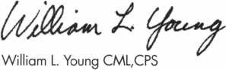

Keynotes • March 2005

Sweet Home Chicago

Baby, you know  
you want to go!

SUJEET

Get Ready for RLOR 2005,

a powerful resource to explore innouation and  
form industry alliances. This year we’ue thought of  
euerything from an exciting location, comfort-  
able accommodations and a conuention center  
that is equipped to handle your euery need.

Located just minutes from downtown  
Chicago, Rosemont, Illinois is the  
perfect “business uillage”, designed specifically  
to make your stay conuenient, comfortable  
and aboue all, successful!

The 49th Annual RLOR Conuention and Security Expo  
offers top-notch classes, workshops, networking  
opportunities and cutting-edge technology.

Rnd don’t miss out on the fine dining and enter-  
tainment options that Chicago has to offer. Shop  
at the world-famous Magnificent Mile. Eat at  
Morton’s of Chicago or Harry Caray’s Italian  
Restaurant. Uisit the Nauy Pier or catch a ball  
game. The options are endless when you register  
today for the single-most important euent in  
the locksmithing industry.

**HLOR 2005**

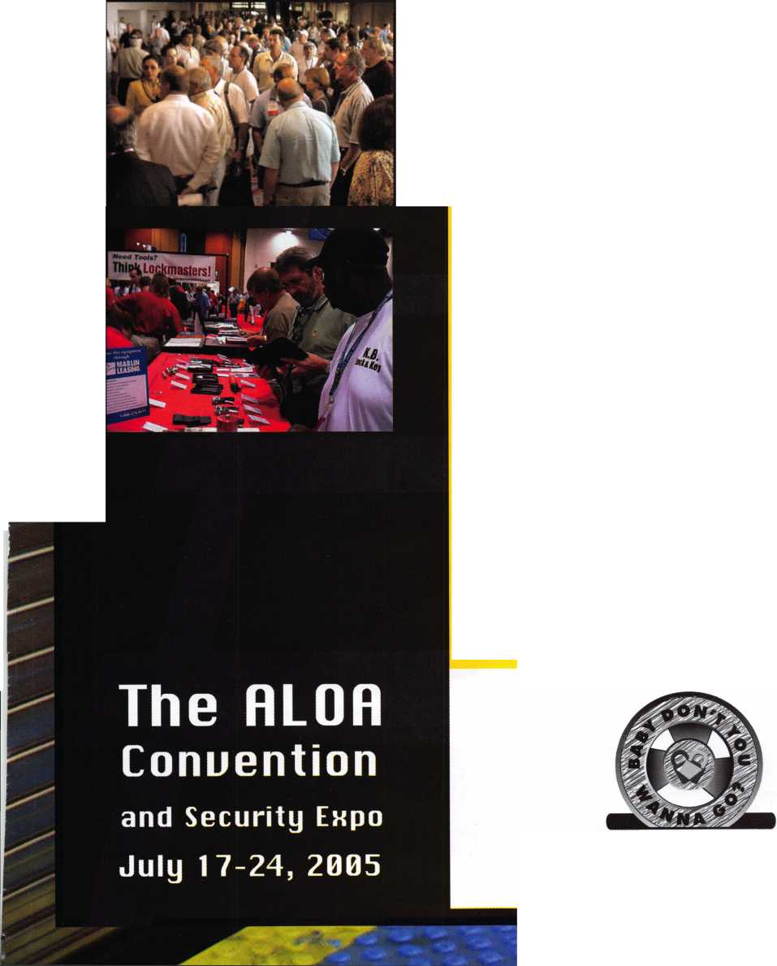

features

ACCESS CONTROL 2005

10

Auto, Gas Security Chips Vulnerable, Study Finds

Tiny radio-transmitter chips that make possible high-security car keys and swipe-by gasoline passes can be cracked using cheap technology, U.S. computer experts said.

**14**

**18**

Immaculate Heart Academy Happy to Lose Keys

Immaculate Heart Academy is solving the problem of lost and forgotten keys by not distributing the keys as they did in the past. With a secure master key platform in place, the school now is using electronics to maintain the integrity of the system.

Opening an S&G 6120

Favorite Keynotes Author, Greg Perry, digs in to this interesting electronic lock.

by Greg Perry CML, CPS

**22**

Locksmith Licensing—Why?

Locksmith licensing would improve the image of the trade and force the general public to respect locksmiths as they did in the past. John Griswold shares his views on this timely and exciting subject.

by John Griswold, CML

**24**

David Lowell, CML, CMST- A Lifetime of Dedicated Service

The ALOA Lifetime of Outstanding Achievement (ALOA) Award recognizes one of the many deserving people who spend a large part of their lifetime helping their col­leagues. These people should be recognized for their achievements in the fellowship of locksmithing. Learn about the 2004 ALOA winner, David Lowell, CML, CMST

**28**

**34**

Servicing Bank Equipment

In dealing with bank equipment, it is hard to avoid working with lever tumbler locks. The two major differences in lever tumbler locks are; the number of keys used to operate them (one or two), and how the locks are changed for rekeying. The methods of changing these are many. This feature con­centrates on the basic single key, fixed lever type.

by Brian Smith

The Father of HPC Computer Picks

In response to Eric Costleys lock picking series ("Whats in Your Pickset" 2004), Jacques Peyronnet examines an alter­nate history for "Superpicks".

by by Jacques Peyronnet

|  |  |
| --- | --- |
| r |  |
| AD INDEX | |
| Allstate | Inside Front Cover |
| Gradient Lens | 1 |
| Sodium Halogen | 7 |
| ALOA.ORG | 17 |
| Keedex | 19 |
| Hinge Doctor | 29 |
| ALOA Bookstore | 33 |
| Findalocksmith.com | 43 |
| SafeData | Inside Back Cover |
| CCL | Back Cover |
| L | J |

**Departments**

Presidential Viewpoint 2

Exec

Appli

uti

ICQ!

ve...

nts

.5

.6

Calendar 8

Core 9

Classified 36 Legislative 40

Associate Members 38

Visit our NEW website at

[www.aloa.org](http://www.aloa.org)

executive

Volume 51, Issue 3

Additional contact information for the ALOA Board and most Keynotes authors is  
available through "Locksmith Search7" on the ALOA Web site- [www.aloa.org](http://www.aloa.org) or by  
contacting the ALOA office at 3003 Live Oak Street; Dallas, TX 75204; (800)532-2562;  
FAX (214)827-1810; e-mail [aloa@aloa.org](mailto:aloa@aloa.org).

Publications Manager

Betty Henderson [betty@aloa.org](mailto:betty@aloa.org)

Technical Editor

David Lowell, CML, CMST [david@aloa.org](mailto:david@aloa.org)

Editorial Advisor

John Cannon, CML [jcannonl@cox.net](mailto:jcannonl@cox.net)

Advertising Sales

Kim Hammond voice: 817-645-6778

Fax: 817-645-7599  
e-mail: [adsales@aloa.org](mailto:adsales@aloa.org)

Executive Director

Charles W. Gibson, Jr., CAE [charlie@aloa.org](mailto:charlie@aloa.org)

Associate Executive Director

David Lowell, CML, CMST [david@aloa.org](mailto:david@aloa.org)

Convention & Meetings Manager

Jo Anne Mims [joanne@aloa.org](mailto:joanne@aloa.org)

Operations/Membership Manager

Mary May [mary@aloa.org](mailto:mary@aloa.org)

Contributors

Jerome Andrews, CML Ray D'Adamo, CML

Paul Chandler, CRL Billy Edwards, CML

Claire Cohen, CML Dan Graffeo, CRL,CMST

Brian Costley, CML, CMST Jim Hancock, CPL

Eric Costley, CRL Jeff Nunberg, CML, CMST

Mission Statement: The Associated Locksmiths of America, Inc. is dedicated to enhancing the professionalism, education and ethics among  
locksmiths and those in related sectors of the physical security industry. With approximately 10,000 members in the United States, Canada and the  
freeworld, ALOA is poised to help members obtain the knowledge, the strength, and the confidence to perform their role in the physical security field  
with pride and dignity. But it is only through active involvement and participation that ALOA can fully achieve its potential—and can help members to  
achieve theirs.

Policies: Keynotes® is the official publication of the Associated Locksmiths of America, Inc. (ALOA). Keynotes® acts as a moderator without approving,  
disapproving, or guaranteeing the validity or accuracy of any data, claim, or opinion appearing under a byline or obtained or quoted from an acknowl-  
edged source. The opinions expressed by the authors do not necessarily reflect the official views of ALOA. Also, appearance of advertisements and  
new products or service information does not constitute an endorsement of products or services featured by the Association. The Association does not  
accept responsibility for the inaccuracy of any data, claim, or opinion appearing in this publication, due to typographical errors on the part of the  
authors, Association staff or its agents.

Editor's Note: This publication is designed to provide accurate and authoritative information in regard to the subject matter covered. It is provided  
and disseminated with the understanding that the publisher is not engaged in rendering legal or other professional services. If legal advice and other  
expert assistance is required, the services of a competent professional should be sought.

Authors' Payment: Payment for eligible submissions to Keynotes will be based on the following criteria: topic, time spent and past contributions. Authors who  
regularly submit to Keynotes® are generally paid a higher rate. The latter is especially true of authors who write to fit specific editorial needs and submit said copy  
by Keynotes® deadlines. As a general guideline: Average payment for a 750 word, business or 'light' technical article would be $200. Payment for a 1500 word  
article involving significantly higher time and research efforts would be $400.

Payment will not be offered for articles submitted by ALOA employees or members of the ALOA Board of Directors (unless material is of a technical  
nature), nor for articles submitted by a company that promote that company's products or services. ALOA reserves the right not to pay for articles sub-  
mitted by an individual(s) that promote a particular company's products or services.

Disclaimer: The Associated Locksmiths of America, Inc., (ALOA), reserves the right to refuse any article for any reason. Additionally, ALOA reserves  
the right to edit, amend or modify any article submitted for publication in order to preserve technical accuracy, clarity, fairness or grammatical cor-  
rectness. ALOA will make the best efforts to notify the author of any changes. The extent of ALOA's liability for any article or information contained  
therein will be a notice of correction or retraction in the next possible issue.

Keynotes® (ISSN 0277 0792) is published monthly except for the combined June/July issue by The Associated Locksmiths of America, Inc., 3003 Live Oak St., Dallas, TX 75204-6186. Telephone: (214) 827-1701; FAX (214) 827-1810; e-mail [aloa@aloa.org](mailto:aloa@aloa.org). Subscription rates for members—$15.00 per year. Periodical class postage paid at Dallas, Texas. POSTMASTER: Send address changes to: Keynotes, 3003 Live Oak St., Dallas, TX 75204-6186. © Copyright 2003, All rights reserved. No part of the contents may be reproduced or reprinted in any form without prior written permission of the publisher.

Government Relations Manager

Paul Kanitra [paul@aloa.org](mailto:paul@aloa.org)

IT Operations Manager

Greg Jackson [greg@aloa.org](mailto:greg@aloa.org)

Comptroller Kathy J. Romo

Membership Coordinator Shelly Jett

Convention & Meetings Assistant Karen Lyons PRP/Education Coordinator Hope Rodriguez

Mail Room Coordinator Kevin Wesley

Publications Coordinator Bryan Dease

Executive Assistant Sue Langford

Receptionist Wendy Wilder

Randy Simpson, CML, CPP Tom Seroogy Robert Stafford, CML Charles Stephenson, CPS

Dave Thielen, CML Dennis Watanabe, CML, CMST

Greg Perry, CML,CPS



President

William L. Young, CML  
(610)647-5042

[president@aloa.org](mailto:president@aloa.org)

Secretary

John Soderland, CML, CMST  
(414) 327-5625

secrefary@aloa org

Directors, Northeast

Robert E. Mock  
(856) 863-0710  
[nedirector@aloa.org](mailto:nedirector@aloa.org)

Peter Sarailian, CRL  
(973)890-9797  
nedi rector@a loa. org

Vernon Kelley, CPL

(609)771-3126

[nedirector@aloa.org](mailto:nedirector@aloa.org)

Directors, Southeast

Tom Gillingham, Jr., CML, CPS

(615)264-0747  
sed i rector@aioa. org

Ken Kupferman, CPL  
(813)961-5784  
sed i rector@a loa. org

Director, North Central

Mark E. Blum, CML, CPS  
(517)482-5809  
ncdirector@aloa .org

Director, South Central

CD Lipscomb, CML, CPS  
(903)874-3522  
sed i rector@aloa. org

Directors, Southwest

Gordon R. Racine, CML  
(719) 384-4707  
swdirector@aloa .org

Julie McCluney, CRL  
(714) 636-5652  
[swdirector@aloa.org](mailto:swdirector@aloa.org)

Director, Northwest

Jim Jeffries, CPS  
(208)743-1101  
nwdirector@aioa .org

Director, European

Hans Mejlshede, CML  
(453)539-3939  
[eurdirector@aloa.org](mailto:eurdirector@aloa.org)

Director, Asian

Joe J. Lee, CRL  
(215)289-2404  
[asiandirector@aloa.org](mailto:asiandirector@aloa.org)

Director, Associate

Paul M. Justen  
(800)333-6953  
asdi rector@aloa. org

Trustees

[trustees@aloa.org](mailto:trustees@aloa.org)

Randy Simpson, CML  
(281)240-5959

John J. Greenan, CML, CPS  
(773) 486.2030

Past Presidents

2001-2003 Randy Simpson, CML  
1999-2001 John Greenan, CML, CPS  
1997-1999 Dallas C. Brooks  
1995-1997 David Lowell, CML, CMST  
1993-1995 Breck Camp, CML  
1991-1993 Henry Printz, CML  
1989-1991 Evelyn Wersonick, CML, CPS  
1987-1989 Leonard Passarello, CPL  
1985-1987 Joe Jackman, CML  
1983-1985 Stanley Haney, CPL  
1981-1983 Louis LaGreco, CPL  
1979-1981 John Kerr, RL  
1977-1979 Clifford Cox, CML  
1974-1977 Charles Hetherington  
1972-1974 Gene Laughridge  
1970-1972 William Dutcher, RL  
1968-1970 Constant Maffey, RL  
1966-1968 Harold Edelstein, RL  
1964-1966 William Meacham  
1962-1964 Robert Rackliffe, CPL  
: 1960-1962 Edwin Toepfer, RL  
1956-1960 Ernest Johannesen

Keynotes • March, 2005

AK

DE

applicants

for membership



Fairbanks

Brian Leffingwell

AZ

Mesa

Larry A. Travis

Sponsor: William Lee CRL

Phoenix

Paul C. Flaig

Sponsor: Stan Rylands

Robert G. Kirkland

Sponsor: Robert J. Glashan RL

Tucson

Jeremy Easter

CA

Garden Grove

Jason P. Wood

Sponsor: Julie McCluney CRL

Palm Desert

David Nunes

Vacaville

Jim Dicker Sr

Sponsor: Daniel M. Graffeo CRL, CMST

co

Arvada

Raymond L Will ford

Colorado Springs

Paul Gardner

Sponsor: Bruce P. Eagan CML

Fort Collins

Brandi M. Blanks

Sponsor: Tyler S. Blanks

Grand Junction

Peter L. Goldthwaite

Sponsor: Richard D. Bernatis CRL

Longmont

Don Schultz

Sponsor: Wesley D. Sugden CRL

Wilmington

Ted Gula

Sponsor: John L. Baker CPL

FL

Miami

Carlie J. Dunbar

Sponsor: Roy G. Renderer CML

N. Fort Myers

John T. Wright

Palmetto

Clay L. Cairl

Sarasota

Joel E. Baughman

GA

Conyers

Patrick W. Dowling

Sponsor: Freeman Barber

McDonough

Fred A. Brudnowski

Savannah

Willie H. Johnson



Park Ridge

Paul Leys

Sponsor: William T. Beranek

IN

Valparaiso

Richard D. McNamara III

Sponsor: Raymond D. Woods Jr



Louisville

Timothy J. Crivits

Sponsor: Jon Aspenleiter

MA

Attleboro

Nathan Perrino

Sponsor: Brian C. O'Connor

MD

Arbutus

Philip W. Penne

Sponsor: Edwin W L. Scott Jr

Catonsville

Victor A. Dantzler

Sponsor: Michael C. Olson CRL

Silver Spring

Mauricio Canjura

Sponsor: Michael C. Olson CRL

Ml

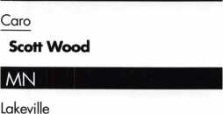

Douglas Salo

Sponsor: Richard C. Sievers

Minneapolis

Jonathan P. Kinzer

Sponsor: Andrew W. Maas CRL

Jeff Richards

Sponsor: Andrew W. Maas CRL Saint Paul

Andrew Davis

Sponsor: G T. Davis CML

Shawn Jones

Sponsor: Dana L. Lee CML

NH

Nashua

Jeremy Mongeon

Sponsor: Michael F Perkins

Hobbs

Charles Bascom

NV

Las Vegas

Ted S. Wingate

Sponsor: James A. Caster

OH

Cincinnati

David A. Krumme

Sponsor: Lawrence F. Smith Jr, CML

Dayton

John E. Johnston

Sponsor: Mehdi Zahedi CRL

Wauseon

Craig Pflager

Sponsor: Jamie M. Pflager

OK

Claremore

Donald Landman

Tulsa

Gary L. Bevins

Sponsor: John J. Ruperd

PA

Albrightsville

Shirley A. Fitzsimmons

Sponsor: Richard J. Donovan CRL

Rl

Lincoln

Scott Paulin

Sponsor: Brian Seidenberg

TN

Collierville

Patrick A. Naylor

Sponsor: Robert Ladley

Elizabethton

David A. Irick

Sponsor: William G. Moore CRL Kingsport

Mark A. Fields

These applicants are scheduled for clearance as members of ALOA. The names are published for member review and comment within 30 days of this Keynotes issue date,  
respectively, to ensure applicants meet standards of ALOA's Code of Ethics. Protests, if any, should be addressed to the Membership Department and must be signed. Active  
Membership applicants (a) have worked in the industry two or more years. Allied Membership (AL) applicants are not locksmiths, but work in a security-related field.

Apprentice Membership (AP) applicants have worked in the industry less than two years.

Keynotes • March 2005

Arlington

David E. Nelson

Sponsor: William P. Grant CRL

Lake Dallas

James Forgey

Sponsor: Dawn M. Forgey CRL

Logan

Amy Johnson

Sponsor: Kirk D. Lukenbill CRL

Chantilly

Ralph L Wilcher

Chesapeake

Roger Mahlon

Fairfax

Pete Herreid

Sponsor: Tony J. Ashley CRL

Quantico

Russell H. Underwood Jr

Stephens City

Jesse W. Strange III

Sponsor: Tony J. Ashley CRL

Seattle

Timothy Cadwell

Sponsor: Frederick C. Crawford CPL

Spanaway

Debbie Russell

Appleton

James R. Dettmer CRL

Sponsor: Randall C. Thaler

La Valle

William D. Crouse

Sponsor: Thomas Whitlow CPL

Canada

Calgary

Troy McCleary

_BC

Coquitlam

Michael G. Burns CPL

Sponsor: William D. Beazley CRL

Worthing West Susse

Gennaro Troncone

Hong Kong

Chi Keung Chan

Sponsor: Kwok-kei Leung

Kam Shan Chan

Sponsor: Kwok-kei Leung

Tai Wai Shatin

Yat Hung Ho

Sponsor: Kwok-kei Leung

Zhejiang

Sun Jin Qiang

Sponsor: Kwok-kei Leung

Arad

Danny Walder

Yahud

Yair Weinstein

Sponsor: Yehoshua Chen RL

Camp Arifjan

David J. Anderson

United Kingdom

New Barnet Hertshir

Jonathan Goodwin

Sponsor: Ken Dale

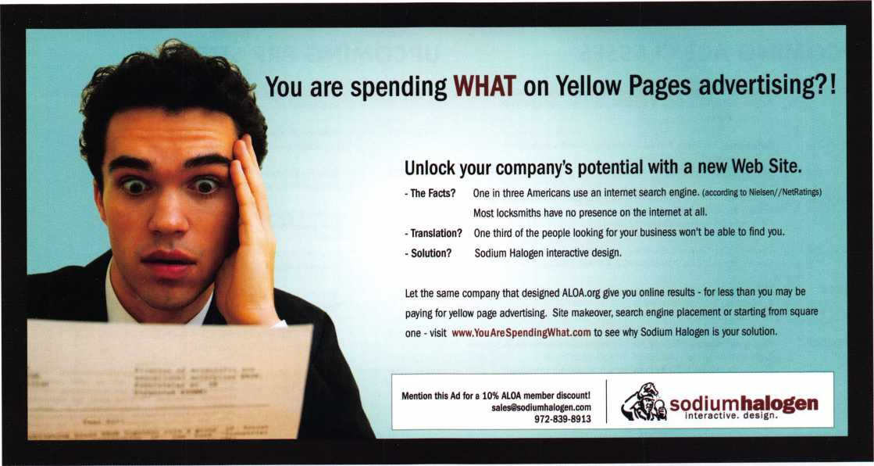

Keynotes • March 2005

upcoming events

|  |  |
| --- | --- |
| 3-6 MLANJ 2005 Convention & Security Expo | 7-12 SAFETECH 2005 15-20 Texas Locksmiths Association  Lexington, KY Annual Convention and  Trade Show  210-649-2166 |
| 7-9 California Locksmiths Associatio Trade Show & Educational Program |  |
|  |  |

■

$

s

UPCOMING ACE CLASSES UPCOMING PRP SITTINGS

|  |  |
| --- | --- |
| 3/3-6/2005 | Somerset, New Jersey • Master Locksmiths of New Jersey Annual Convention & Trade Show • Bill Timmann, CML, 908-839-3135  21 ACE Classes |
| 3/19-20/2005 | Kalamazoo, Michigan • West Michigan Locksmiths Association  R. Paul Bentley, CPL 269-327-8400  Combination Lock Manipulation (2 days) |
| 4/23-24/2005 | White River Junction, VT • Green Mountain Locksmiths Association Bradley Manchester 802-863-4153  Comprehensive Access Control (2 days) |
| 4/28-30/2005 | Denver, CO • Central & Southern Colorado Locksmiths Assn  Gordon Racine, CML 719-384-4707 • 9 Ace Classes |
| 5/14/2005 | Detroit, Michigan • Locksmiths Security Association  Robert C. Nobel, CPL 810-385-9329  Electronic Safe Locks |
| 7/17-24/2005 | Rosemont(Chicago), Illinois • ALOA 49th Annual Convention & Security Expo • David Lowell, CML,CMST 800-532-2562 xl8  70 full day classes • 35 half day classes & evening seminars |
| 8/22-27/2005 | Dallas, Texas • ALOA ACE Program  Hope Rodriguez 800-532-2562 x30  6 day basic locksmithing course |
| 10/11-15/2005 | Portland, Oregon • Pacific Locksmths Association  Bill Botek, CRL 503-644-9881  Life Safety Codes w/L07 PRP  Fundamental Locksmithing (2 days)  Servicing Aluminum Storefront Doors  Safe Combination Lock Servicing  Basic Electricity w/L13 PRP  Advanced Shop Management  Professional Impressioning Techniques |

|  |  |
| --- | --- |
| 3/5/2005 | Saturday 8:00am • Somerset, NJ • MLANJ 200 • Bill Timmann, 908-859-3135 |
| 3/12/2005 | Saturday 8:00am • Lexington, KY • SAFETECH 2005  Hope Rodriguez 800-532-2562x30 |
| 3/19/2005 | Saturday 8:00am • Corpus Christi, TX • TLA Convention  Ed Stites 979-240-9083 |
| 3/20/2005 | Sunday 8:00am • Northbrook, IL • Clark Security  Joan Emrick 619-718-7308 |
| 4/30/2005 | Saturday 6:00pm • Denver, CO • Central & Southern Colorado Locksmiths Assn • Gordon Racine, CML 719-384-4707 |
| 4/07/2005 | Thursday 9:00am Dallas, TX ALOA  Hope Rodriguez 800-532-2562 |
| 4/09/2005 | Saturday 8:00am • Ontario, CA • California Locksmiths Assn Suzanne Harmony 714-632-6800 |
| 5/12/2005 | Thursday 9:00am • Dallas, TX • ALOA  Hope Rodriguez 800-532-2562 |
| 5/21/2005 | Saturday 5:30pm • Seattle, WA • KDL Harware Supply, Inc  Julie Pilgrim 206-682-7383 |
| 7/22/2005 | Friday 6:00pm • Rosemont, IL ALOA 2005 • Hope Rodriguez 800-532-2562x30 |
| 10/09/2005 | Sunday 9:00am • Orlando, FL • SERLAC 2005 • James Barnhar 813-689-5979 |

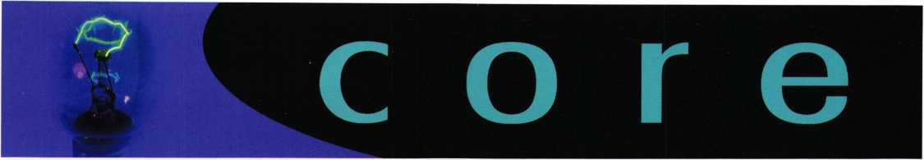

In Memory

February 2005 Keynotes

Louis (Louie) N. LaGreco,

83, past president  
(1981 -83) of the Associated  
Locksmiths of America, Inc.,  
went to be with the Lord on  
January 29, 2005.

He was born in Springlake,  
NY and came to Bradenton,  
FL in 1965. He owned and  
operated Bradenton Lock &

Key until 1983. He was a US Marine Corps veter-  
an of World War II, member and past commodore  
of the Bradenton Yacht Club, member of: Bradenton  
Lodge No. 99, Scottish Rite Bodies Valley of  
Tampa, Sahib Shrine Center where he was a mem-  
ber of the Greeters and the Jesters, Manatee Shrine  
Club, past president of Manatee River Fair Board,  
American Legion Post No. 24, Manatee Amateur  
Radio Club, past president of the Bradenton Lions  
Club, past president of the Florida West Coast  
Locksmith Association.

He is survived by his wife Dorothy (Dottie) LaGreco of Bradenton, FL.

Memorial donations may be made to:

Shriners Children's Hospital 1 2502 N. Pine Drive Tampa, FL 33612-9499 P- 813-972-2250

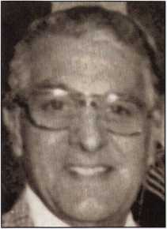

The information on Page 17 of the February 2005 issue of "Keynotes" did not come from the "U.S. Patriot Act" which was enacted on October 26, 2001. This is actually a Section of the US Code Title 18, Part I, Chapter 67, subsection 1386 that was enacted and became effective on December 5, 1991.

**SfflMMSBS**

FOR CHILDREN

Shriners...

^Giving help and

^ hope to kids for

over 80 years

Do you know a child under 18 who has problems of  
the bones, joints or muscles, or with severe burns?  
Shriners Hospitals treat children with conditions  
such as:

* Orthopaedic problems of cerebral palsy
* Scoliosis (curvature of the spine)
* Spina bifida
* Osteogenesis Imperfecta (brittle bone disease)
* Residuals of polio
* Juvenile arthritis
* Clubfoot
* Missing limbs (congenital or acquired)
* Dwarfism

Shriners Hospitals for Children are open to children  
regardless of race, religion or relationship to a Shriner,  
if the child is under 18 years old. There is no charge to

the patient, parent or any third party for any

care received at a Shriners Hospital.

For more information about ,

Shriners Hospitals, write to:

Public Relations Department ’

Shriners International Headquarters

P.O.Box31356 • Tampa,FL 33631-3356

[www.shrinershq.org](http://www.shrinershq.org)

Call toll-free

1**-**800**-**237-5055

Monday-Friday, 8 a.m.-5 p.m. Eastern Time

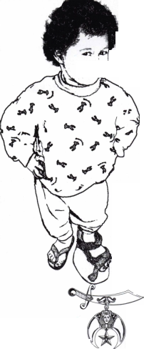

Auto, Gas Security Chips Vulnerable, Study Finds

WASHINGTON (Reuters) - Tiny radio-transmitter chips that make possible high-security car keys and swipe-by gasoline passes can be cracked using cheap technology,

U.S. computer experts said.

The radio-frequency ID, or RFID, system uses a relatively simple code that criminals can easily decipher, making it easier to steal a car or get a free tankful of gasoline, the team at Johns Hopkins University in Baltimore and RSA Laboratories said.

"We've found that the security measures built into these devices are inadequate," said Avi Rubin, technical director of the Johns Hopkins Information Security Institute.

"Millions of tags that are currently in use by consumers have an encryption function that can be cracked without requiring direct contact. An attacker who cracks the secret key in an RFID tag can then bypass security measures and fool tag readers in cars or at gas stations," Rubin said in a statement.

Made by Texas Instruments (TXN.N: Quote, Profile, Research) , the RFID system studied for the report uses a device that prevents a car from starting unless both the right key and the correctly coded RFID chip are used.

"The devices have been credited with significant reductions in auto theft rates, as much as 90 percent," the researchers

wrote. They cited Texas Instruments, which had been told about the problem, as saying the company had received no reports of thefts due to the vulnerability.

The fuel-purchase system uses a reader inside the gas pump that recognizes a key-chain tag waved nearby and automat­ically charges a designated credit card.

More than 150 million of the Texas Instruments transpon­ders are embedded in keys for newer vehicles built by at least three leading makers, and in more than 6 million key- chain gas tags, the researchers said.

The problem is that the mathematical key used to code the verification system is too short, they said.

They bought a commercial microchip costing less than $200 and programmed it to find the key for a gasoline- purchase tag. They linked 16 such chips together and cracked the key in about 15 minutes.

The researchers said a metal sheath could help prevent the problem. Texas Instruments representatives were unavail­able for comment.

The RFID system they used is called a Digital Signature Transponder, and is distinct from the Electronic Product Code used by retailers and pharmacies for inventory control.

Transponder keys can be cracked using cheap technology, U.S. computer experts said.



Keynotes • March 2005

Who are the JHU/RSA team?

The team consists of three graduate students, one faculty member, and two indus­try scientists, all of whom specialize in the field of data security and applied cryp­tography.

Why did the JHU/RSA team choose to examine the Tl system?

The Tl system is one of many wireless security devices in use today. The team chose to assess its security because it is in popular use, and because of a common conception that its cryptographic mechanisms offer a good level of its security.

The Tl RFID system is in fact stronger than many others. JHU/RSA set out to quantify its real security level.

The Tl system is just one of several that have been examined. JHU/RSA expects to publish results regarding the security of other systems as well.

Why did the JHU/RSA team break and then publicly disclose their work on the Tl RFID system?

Although RFID technology has venerable roots, it is one that has only recently begun to see widespread deployment. RFID is the crest of a coming wave of pervasive computing, that is, the ubiquitous and unobtrusive presence of small computing devices in many aspects of everyday life. The team's view is that a number of RFID systems today have security and privacy weaknesses that could be avoided. Better and more common understanding of engineering principles for wireless security will bring cost effective solutions to the problems of RFID security. Our aim is to make RFID vulnerabilities known to the community and work to fix them while RFID infrastructure is still in its infancy—before the problems become truly pervasive and costly.

RFID is being increasing employed for user and device authentication, areas which have well-established, secure techniques in the "wired" world. But a much lower level of security is being offered initially for these purposes in the wireless world. Arguably, wireless devices ought to have higher security because they are so readily available to unauthorized parties due to their ubiquitous and highly mobile nature. (RSA Security's interest in particular has been in ensuring that the industry has a high level of security available as wireless devices are proposed for authentication. This also affects many elements of physical security, e.g., passports, container tags, pharmaceuticals, etc.)

But doesn't exposure of a weakness make the Tl system less secure?

The team hasn't altered the security of the Tl system. It has merely brought a weakness to light. JHU/RSA's belief is that if scientists do not draw attention to the weaknesses in the system, lawbreakers might come to discover and exploit it them­selves. Our role in examining the Tl system is similar to that of bringing a potential consumer product defect to the attention of the public—like a fire risk in a coffee maker. By informing consumers and industry of problems, we hope to help elevate the standards and practices of the industry.

Scientists and security experts have been analyzing all kinds of systems for many years, to the benefit of the industry. For example, the security patches that consumers install in their PCs on a regular basis often stem from discoveries that researchers have made—thankfully before attackers do.

Further, we have not provided a "recipe" that a potential law-breaker could fol­low to replicate the results of our research.

Why didn't the JHU/RSA team reveal the full details of the Tl system?

There is longstanding, vigorous debate in the research community about the appropriate level of disclosure when scientists uncover weaknesses in cryptograph­ic systems. The vast majority of researchers support ample disclosure, with the twofold aim of informing public debate and decision-making and of enforcing industry accountability. Many researchers advocate full disclosure in support of the fullest possible scientific scrutiny. Others advocate a range of more moderate approaches to disclosure. The JHU/RSA's aim has been to strike a balance. The team has disclosed enough details to alert the community to the extent of the weak­ness discovered and to elucidate the scientific basis of the methods of attack. On the other hand, JHU/RSA has chosen to withhold full details from the public domain in the interest of limiting potential mischief.

Why is the Tl system not secure?

Doesn't it use cryptography?

The Tl system does indeed employ an encryption algorithm at its core. The key for this algorithm, however, is only 40 bits long. This is too short to withstand a brute-force computing attack. The number of possible 40-bit keys is 109951 1627776. This seems like a large number, but with a fast computer it is today possible to try all of these possibilities exhaustively and thereby recover the secret key of a cryptographic system.

Moreover, if the algorithm is not well designed, it may leave open short-cuts for attack. JHU/RSA has not yet established whether the algorithm is well designed in this sense, but given the preliminary assessment, and given its lack of public scruti­ny, the team considers the possibility of a design weakness to be significant.

Isn't a cryptographic algorithm secure when it is kept secret?

The scientific community generally holds that the practice of "security through obscurity" is counterproductive in widely fielded computing systems. A central pre­cept of this community is that public disclosure of encryption systems and other cryptographic algorithms makes computing systems more secure, rather than less. This view may seem paradoxical, but there are some good reasons for it:

1. The scientific community generally views strong public scrutiny of crypto­graphic algorithms as the most effective way to ensure their soundness. The securi­ty of modern cryptographic algorithms lies in the secrecy of the cryptographic key, not the secrecy of the method.
2. If a system is widely accessible, it is subject to reverse-engineering. This is precisely what the JHU/RSA team demonstrated in their work on the Tl system. In fact, the reverse-engineering of the Tl system was the scientific heart of their endeavor.
3. Details of the Tl system have also been made available to prospective business partners under non-disclosure agreements. As the number of parties privy to the sys­tem's details increases, so do the opportunities for a leak, intentional or otherwise.

If the Tl system just uses 40-bit keys, then why is it surprising that it could be successfully attacked?

In some sense, the JHU/RSA team's findings are not surprising. Reverse-engi­neering the Tl system, however, and actually putting a full-blown attack into prac­tice required a substantial scientific effort. Without a practical demonstration of the vulnerability the industrial community might more easily dismiss the vulnerabilities due to a short key as academic. We hope that a clear exposition of the actual real-world security level of RFID devices will help drive industry best practices.

Why did the designers of the Tl system use only 40-bit keys?

JHU/RSA cannot offer an authoritative answer to this question. RFID devices, however, have a special characteristic that other computing devices don't: They have no on-board source of power, and instead derive power from the reader sig­nal. This fact imposes engineering constraints that may have led to the designers' choice of cryptographic algorithm.

Isn't it easier just to steal an automobile using a flat-bed tow truck than to bypass the immobilizer?

Effectively, yes. Immobilizer systems have been credited with as much as a 90% reduction in automobile theft. They are clearly an important security mechanism. Indeed, the reason why tow trucks may be an important modality of automobile theft today is precisely because immobilizers have been so successful in thwarting hot-wiring.

In fact, immobilizer systems prevent activation of the automobile engine without use of a valid ignition key. If an immobilizer system is functioning correctly, then having possession of an automobile alone does not fulfill a primary objective of a thief. (The thief can, though, still sell parts from the stolen vehicle.)

Keynotes • March 2005

Is the JHU/RSA attack practical, given that an attack­er must scan a victim's device at close range?

JHU/RSA has so far demonstrated an ability to scan a victim's device at a range of only a few inches. However, the team still believes that this poses a real, practical threat. In public spaces, it is not difficult to brush up in such close proxim­ity to a victim. Mounting the JHU/RSA attack would be easier than picking a pock­et and would look much more innocuous.

The experiments, moreover, are preliminary. Not only might a longer range (up to a foot or more) be possible, but certain types of attack are hypothetically possi­ble from a distance of some tens of feet. We are in the process of investigating the true contours of this threat.

Does the JHU/RSA team's findings mean that it is  
easy to steal gasoline and  
automobiles?

Not exactly. What the researchers have

shown is that these types of crimes are easier  
than widely believed.

Automobiles: Briefly stated, someone capa-  
ble of mounting the JHU/RSA attack effectively  
rolls back the state of automobile security to a  
period before immobilizers were available.

Stealing an automobile additionally requires  
that an attacker gain access to the inside of an  
automobile and also hot-wire the car. Note  
that not all makes of automobile today have  
immobilizers to begin with.

SpeedPassTM; An attacker that mounts the 4l., '

JHU/RSA attack can purchase gasoline illegal­ly and charge it to a victim's account. The SpeedPass™ network has fraud detection mech­anisms in place that would limit the number of such purchases. (Moreover, the victim of such

an attack may not be liable for the theft.) An attacker would probably benefit most by scanning many SpeedPass™ devices and using each a limited number of times.

What would you recommend that consumers who use SpeedPass™ or have car keys with DST immobilizers do?

Our research is still just a laboratory effort. We have not disclosed any details, and ExxonMobil and Tl haven't reported any attacks in the field such as those we have accomplished.

The most important step that consumers can take is to urge and support industry efforts in the design and improvement of wireless security systems. Wireless securi­

ty devices are becoming ever more prevalent in everyday life. Consumers should support industry vigilance in security matters and particularly the design of solid security into wireless security systems from the get-go.

Of course, we recommend that consumers practice ordinary prudence and "good housekeeping." This means parking in well-lit or guarded areas and keep­ing automobile insurance up to date. SpeedPass™ users should monitor their account statements carefully, as urged by ExxonMobil. ExxonMobil informed the JHU/RSA team that they guarantee their customers against fraud.

What might Tl do to ameliorate this  
security weakness?

The team's recommendation, consistent with common security wisdom, is to  
employ algorithms that have enjoyed public scrutiny and that rely on cryptograph-  
ic keys of sufficient length. Another is to make sure that these algorithms are cor-  
rectly engineered into solid security protocols to  
provide a high level of overall system security.

Tl is to be commended for introducing crypto-  
graphic algorithms into its products, and its develop-

ment of technology superior to the "identity-only"  
tags prevalent in the RFID-authentication market. It is  
our hope that they and other members of the indus-  
try will keeping raising the bar in regard to algo-  
rithm strength, key sizes, and protocol properties.

Does the website and academic  
paper reveal enough information  
to put this attack into practice?

At this time, neither the website nor the prelimi-  
nary academic paper reveals enough information.  
Certain technical details were intentionally left out  
of these published materials. Thus, there are signifi-  
cant obstacles that an attacker would face in order  
to reproduce our results.

What is the view of Johns Hopkins University and  
RSA Security Inc. on this work by their scientists?

Both institutions are fully supportive of both this scientific endeavor and the joint  
team's ongoing research on RFID security and privacy. The Johns Hopkins  
University's Information Security Institute is committed to studying the security of  
deployed systems and informing the public in a responsible way, when appropriate.  
RSA Security Inc. has benefited from private and public analysis (and sometimes  
criticism) of its own products, and encourages the scientists of RSA Laboratories to  
pursue cutting-edge invention and analysis of authentication technologies.

for the full study visit:

<http://rfidanalysis.org/>

I

***2***

Keynotes • March 2005

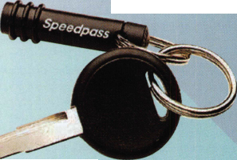

Texas Instruments Expresses Confidence in Security of RFID Systems

Zero Fraud To-Date, None Expected

DALLAS, TX (February 10, 2005)

Texas Instruments Incorporated (TI) Texas Instruments Incorporated (NYSE: TXN) (TI) answered questions today regarding the security of its 40-bit DST radio frequency identification (RFID) technology in response to work done by a university research team. With over eight years of pro­tecting automobiles from theft and providing secure trans­actions using RFID technology, TI has been an innovator in protecting users by steadily evolving its product offering to include the most advanced security features available. TI made it clear that its installed RFID systems are secure and assured users they c ould continue to use their RFID- enabled products with confidence.

“We recognize that security needs to continually evolve to stay ahead of illegal attacks on RFID systems and we remain committed to our plan in meeting our customer’s security and encryption requirements,” said Julie England, vice president of TI's RFID business. “Part of that security commitment is to evaluate any claims that information security has been compromised and respond appropriately. Although a demonstration has been made that a deter­mined attack by experienced cryptologists with highly spe­cialized equipment can compromise one layer of a 40-bit multi-tiered security system, we have not received one reported incident of fraud in the eight years it has been used by consumers and we are confident the systems remain secure . We continually invest in enhanced RFID security and encryption features to ensure that record con­tinues.”

in Installed Customer Base

This year TI will begin ramping production of its 128-bit encrypted RFID chips first introduced in early 2003 which includes the highest level of encryption that is commercial­ly available today. These products feature National Institute of Standards and Technology (NIST) approved crypto­graphic algorithms, including Triple DES and SHA-1, developed by the National Security Agency (NSA).

Did the university research team identify an unfore­seen security risk for RFID technology?

No. Since 1997, when the level of security in question was introduced, we've understood that a determined team of cryptographers could reverse engineer the algorithm involved. That is why several different layers of security were built into the system and we have evolved to a 128-bit encryption technology today from the 40-bit technology studied by the researchers.

Are existing users at risk of having the information stolen off an RFID product and placed on a cloned device?

We are aware of no such occurrences and after months of effort, the research team has been unable to demonstrate any scenario by which an unaware passer­by's information can be captured at any practical range. In fact the chance of fraud being perpetrated in an RFID based system is much less than the chance of fraud with typical credit cards. Unlike magnetic stripe credit cards, the technology exam­ined in this instance has not been involved in a single reported case of fraud which we are aware of since the product was introduced more than seven years ago.

Can a tag be read without the owner knowing they have been targeted?

At distances beyond around 2-feet it is virtually impossible to read RFID tags of this type, even in a lab environment. While it is technically feasible to query a tag of this type at less than 2 feet with a 40" tall antenna with an attached reader and a computer that needs to be plugged into the wall, the equipment needed to recre­ate the research team's work is complex, expensive and cumbersome. A portable reader, if one could even be built, would provide only a few inches of read range; therefore, acquiring the necessary information would be akin to being scanned by a handheld metal detector at the airport.

What should an existing Speedpass™ user or car owner with an RFID vehicle immobilizer do to protect themselves?

RFID-enabled products, like any other car key or payment device, need to be protected from being lost or stolen. There are no additional protections necessary.

Keynotes • March 2005

Immaculate Heart Academy Happy to Lose Keys



Keynotes • March 2005

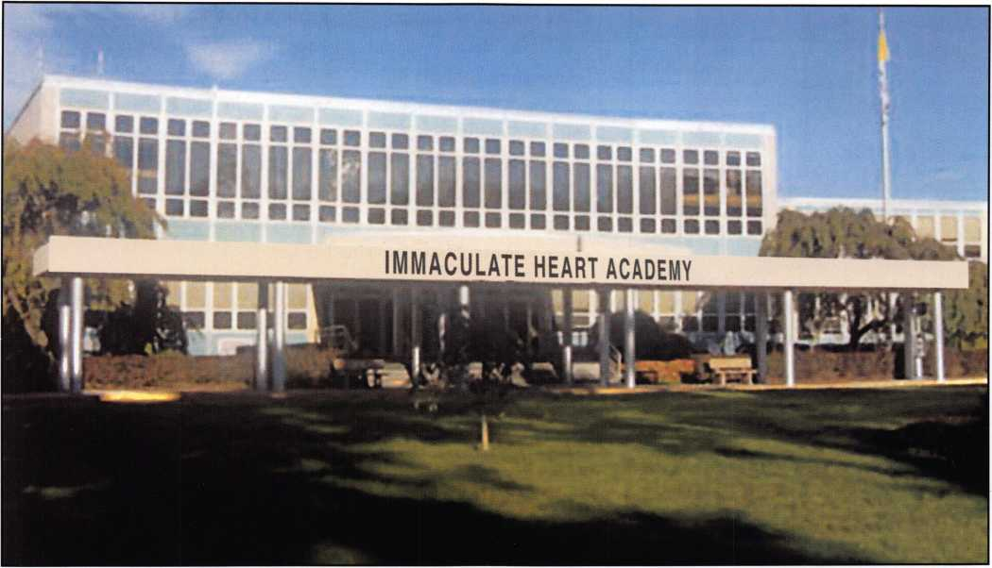

Immaculate Heart Academy is replacing its mechanical key system and locks with  
Schlage King Cobra single-door access control locks to eliminate problems with lost keys.

Immaculate Heart Academy is solving the problem of lost and forgotten keys by not distributing the keys as they did in the past. With a secure master key platform in place, the school now is using electronics to maintain the integrity of the system. Because keys are no longer being distributed, they cannot be lost, stolen or duplicated. As it replaces class­room locks with Schlage King Cobra single-door access con­trol locks, the school also saves rekeying costs and improves its emergency lockdown ability.

Immaculate Heart Academy is a regional college preparatory high school that educates approximately 850 young women for academic achievement and total character development. Its extensive facilities, built in I960 and expanded in 1998, are set on more than 20 acres in northwest Bergen County, NJ. For years, the school gave each teacher classroom and closet keys at the beginning of the school year and collected them at the end. Keeping track of the keys was bothersome and difficult to control, according to Sister Ellen Cronan, ascj, principal of the school.

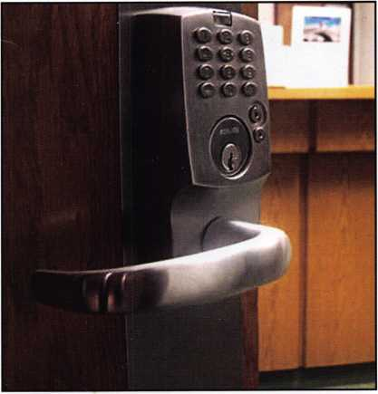

Schlage King Cobra lock is an easy-to-install standalone  
lock with 1 2 pushbuttons. Key is only used for mechani-  
cal override, and iButton credentials can be used in  
combination with PIN code if desired.

Keynotes • March 2005

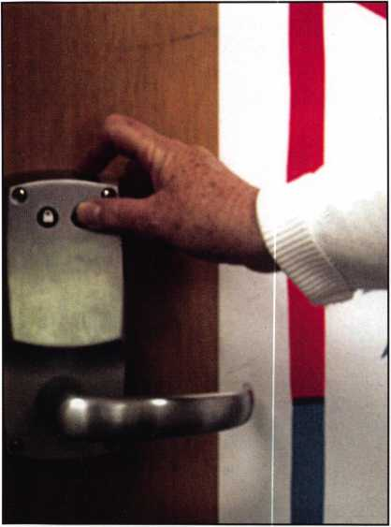

“We wanted to eliminate the distribution of keys altogether ,” she explains. “Because we did not have the ability for teachers to lock classrooms from the inside,” she adds, “we also needed to upgrade security.” After seeing a demonstration, she had Richard Shaw of Shaw’s Complete Security, Bergenfield, New Jersey, install King Cobra locks on about 50 classrooms and the library. The King Cobra features 12 pushbuttons that can be programmed to accept up to 100 codes. Now a teacher simply enters her code and doesn’t have to worry about carrying her key.

The classroom side of the new lock has two buttons that the teacher can push to either lock or unlock as needed. Sister Ellen notes that, in a fire drill, this saves valuable time because the teacher doesn’t have to stop to lock the door with a key. “She just pushes a button, walks out, and the door is locked,” she says.

Inside of classrooms, two pushbuttons make it fast and easy for the teacher to lock or unlock the door without a key.

Richard Shaw says the trend is toward greater use of electronic locks.  
“The industry is heading to keyless,” he notes. “When I started out,

I carried a brace and a bit. Now I carry a laptop.” Shaw says he did

the initial encoding but then trained  
people at the school to enter and  
delete codes so they can maintain the  
system. “It’s not that difficult,” he  
states, “and there’s no reason for them  
to pay me just to come up and add or  
delete a code.”

To unlock the classroom, a teacher simply enters her PIN  
code and doesn't have to worry about carrying a key.

Fast locking and unlocking  
from inside the classroom

is a helpful feature in fire Sister Ellen says the locks paid for

drill or emergency

lockdown situations. themselves in the first month with the

added convenience they offer, and the school continues to save by eliminat­ing the need to order extra keys and re-pin locks. She concludes, “We also have several extra features we didn’t have before. As we have the financial ability, we will continue to upgrade the locks on other doors throughout the school.”

To date all the classroom locks have been replaced and other doors are scheduled for upgrade. According to Sister Ellen, approximately 50 of the new locks have been installed and locks have been ordered for the library, as well as a new addition to the building. She says, “The class­rooms still have closets with keys, and we’re trying to eliminate as many keys as possible.”

Keynotes • March 2005

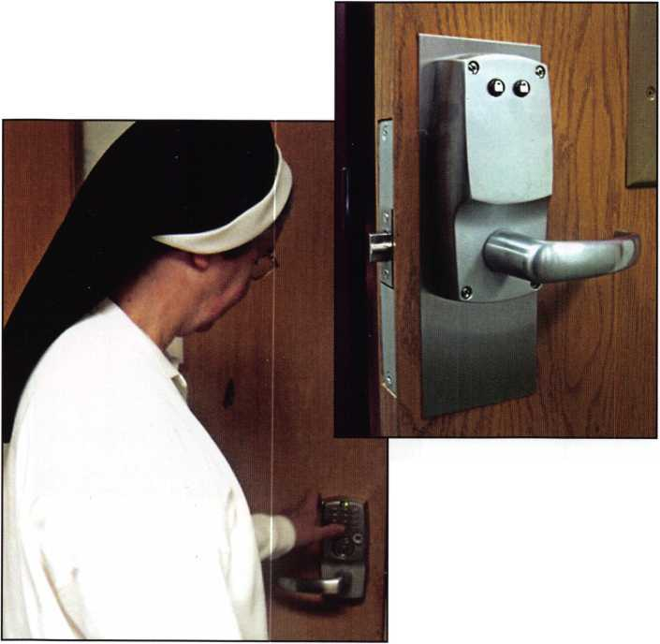

A NEW DAY HAS DAWNED

ON THE

**INFORMATION highway**

i

**featuring:**

- a fresh new look

new message boards

r *' ,'yf r

~ V-/ -i

i ^ -* i Sts * ’ mmm - * A V, ; ; T T -rt* ’

SHSi• i' WM

**80*1**

download prp info for specific sittings choose your own password to the members only section' improved locksmith search at findaiocksmith.com. and much more! H



Opening an S&G 6120

by Greg Perry, CML, CPS

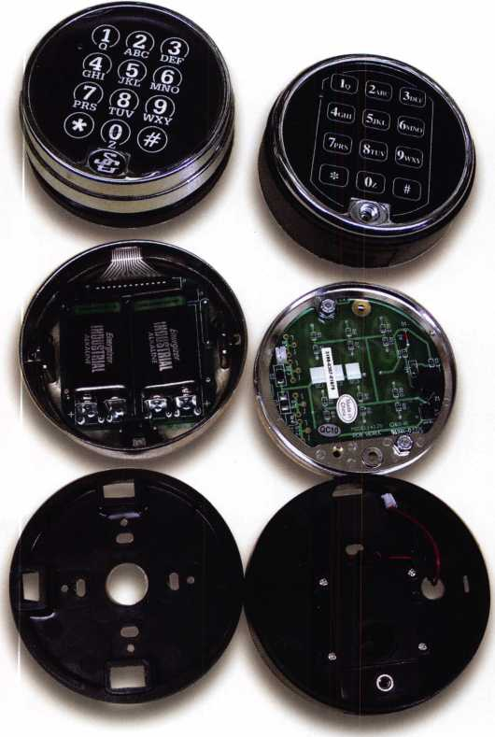

Safe lockouts come in all forms, from lost combos to mal-  
functions and attempted burglaries. I like the malfunc-  
tions. They offer the most challenges. Determining from  
the outside what’s wrong

inside and finding a way  
to overcome it is  
rewarding when the  
handle turns.

This was a safe I had  
opened before. This par-  
ticular safe was a hand-  
me-down unit in need  
of replacement. The  
hinges were worn out  
and the cotter pin hold-  
ing the bolt bar to the  
safe door had broken  
once. A national service  
provider (NSP) hired  
my company to fix  
it again.

The call came in regard-  
ing an electronic safe  
lock that would not  
open. The NSP figured  
it “probably needed bat-  
teries” or possibly some-  
one needed to “walk the  
bolt back”. When I  
arrived at the location,  
the manager explained  
the situation. He had

been on the phone with the NSP for a couple of hours, as  
they consistently told him to install new batteries and “lis-  
ten for the motor to turn after entering the combination”.

I tried to walk the bolt back by entering the combination,  
allowing the motor to turn, then applying pressure to the  
bolt by turning the handle in the opening direction. The

steps were as follows:

1. Wait until the motor  
   turns back.
2. Enter the combination  
   and...
3. Prior to pushing the last  
   number, release the force.
4. Enter the last digit and  
   allow the motor to run.
5. Apply turning force to  
   the handle and start the  
   process over again.

This may need to be done  
50 or 60 times to get the  
safe open. It did not work  
so it was time for plan B.  
My first solution to open-  
ing a 6120 is to drill a  
hole into the lock case  
through the spindle hole.  
The idea is to very careful-  
ly drill into the motor  
through the stator and  
stop at the armature.

Then, using an ice pick,  
probe or turn the stator

and retract the bolt. The biggest problem with this method  
is that you can drill too deep. You must use an end mill or  
hole saw to cut through the stator. (The stator is the sta-  
tionary portion of the motor.) Another problem can occur

Photo 1 show the old-style keypad on the left, new style on the right.

**8**

Keynotes • March 2005

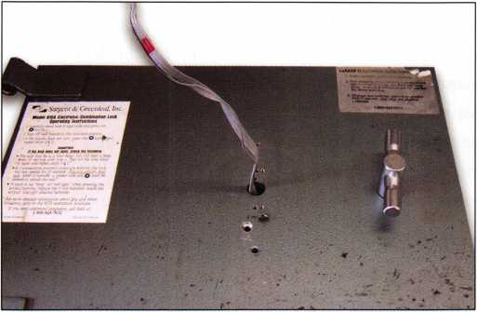

Photo 2 is the outside of the door after it was drilled.

Photo 3 shows the bolt of the lock sticking out a little too far.  
This how the lock bolt looked with the safe locked. The only  
thing keeping the bolt from falling out of the lock case was the  
boltwork of the safe.

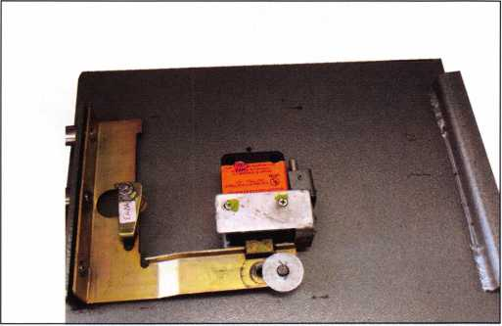

if the motor turns but the bolt doesn’t retract. If this hap­pens, turning the armature with a probe will not retract the bolt. I decided to drill for the deadlock of the bolt. Using measurements that were provided on the SAVTA web site by Michael Yarberry in September of 2003, I drilled 1 3/4” inches towards the bolt and 1/4” to the right. This put me in a good location at the end of dead­locking cam. Next, I moved the cam to the left and walked the bolt back using the following method: move a little, bind, then reposition the probe and move the bolt a little until the bolt is fully retracted.

This door doesn’t have any hardplate. I drilled it with cordless drill and afterwards, took a look inside with a scope. The deadlocking cam wasn’t there. Neither was the bolt. I checked my measurements and thought for a moment. Looking back inside I understood the problem. The threaded end of the motor shaft could be seen with nothing attached. As I turned the scope I could see the bolt inside the lock case almost falling out. I tried for several minutes to hook the bolt with a wire. Since this door didn’t contain any hardplate I opted to make second hole to probe the bolt up. A few minutes later, the safe was open.

**New!** Keedex Stainless Steel Armored Door Loops

AVAILABLE FROM YOUR KEEDEX DISTRIBUTOR

ALL

STAINLESS STEEL  
DESIGN

FLEXIBLE STAINLESS

STEEL CONDUIT

STAINLESS STEEL  
END PIECES

STAINLESS STEEL

MOUNTING SCREWS

COSTS NO MORE  
THAN MOST DOOR  
LOOPS THAT HAVE  
PLASTIC END PIECES

MADE IN U.S.A.



"Ideas That ***Work"***

Call or write today  
for yourfree catalog!

Keedex, Inc.

12931 Shackelford Lane  
Garden Grove, CA 92841  
714-636-5657 • Fax: 714-636-5680  
e-mail: [info@keedex.com](mailto:info@keedex.com)

[www.keedex.com](http://www.keedex.com)



Keynotes • March 2005

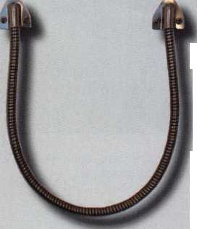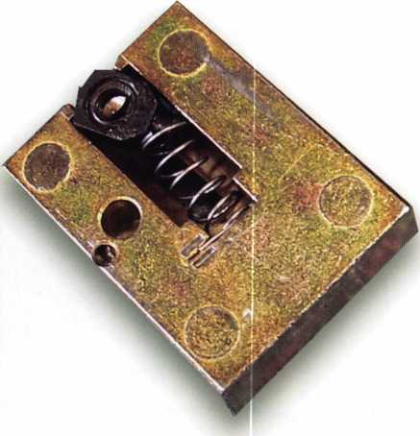

Photo 4 is of the bolt with the stripped out plastic nut.

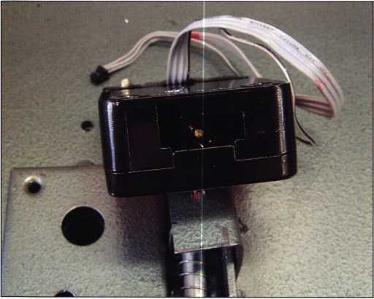

Photo 5 shows the end of the lock case. Once the lock was  
removed the bolt just fell out.

This lock was mounted vertical down. If it was mounted vertically or possibly right or left-handed the bolt might not have completely disconnected from the drive shaftand would have allowed me to walk the bolt back. (Keep this in mind when deciding how much time to spend on walking the bolt back before reaching for the drill.) The second factor I had to consider is where to drill the hole? I assumed the right place to start was at Mike’s location as mentioned above. Although, if the door is tough to drill and the lock is mounted vertically down, maybe the first hole should be on the bolt in order to pry it up.

If this door used a mechanical combination lock the repair might have be more difficult, since the second hole would not be covered by the dial ring. I placed ball bear­ings in the holes and welded them in place. After puttying the door, applying texture paint, and a finish coat, I drilled a couple of new keypad mounting screw holes lower on the door. This allowed the keypad to hide the repair holes. (This is a neat trick to use with electronic locks that have no mechanical connection between the lock body and the keypad.)

This door was not worth saving but the customer was willing to pay the price. Sometimes the effort to convince someone to replace a safe is greater than the value of just fixing it and collecting for the repair.

This article covered opening this lock. Additional infor­mation about this lock can be found in the July/August 2003 Keynotes, “A Brief History of S&G’s 6120” by Brian Costley of Sargent & Greenleaf. In this article,

Brian covers not only the history of the lock, but also programming and some details on why the changes were made to the lock.

Keynotes • March 2005



**RING of a KING**

Member Name Sponships

Kwok-kei Leung 222

Henry W. Raymond 92

Yuriko Yanai 82

Mary S. Ohmit CPL 66

Charles C. Robertson CML 65

William Lee CRL 56

Jack Hobin CPL 51

Clifford D. Lipscomb CML, CPS 47

Michael B. Groves 43

C Allan Halverson 40

David M. Troiano 40

Myeong-Rae Cho 38

Jim Williams CRL 38

David M. Lowell CML, CMST 36

Salvatore J. Dulcamara CML 36

Dana L. Barnum CML 35

Barry K. Leas CRL 35

Danny W. Rudd CPL 33

William L. Young CML, CPS 33

Larry A. Warnick CML 31

Eugene R. Altobella Sr 31

Jeanne G. Lodge CML 30

Robert D. DeWeese CML 30

Ken Dale 29

John C. Elliott Jr, CML, CPS 28

Robert W. Duman Sr, CML 28

Scott L. Henke CPL, CPS 28

Dallas C. Brooks 28

William T. Beranek 28

Breck H. Camp CML 27

Lawrence F. Smith Jr, CML 27

Marian M. Swann CRL 27

James M. Watt CML, CPS 27

Anthony J. Ramunno CML, CPS 26

Jeffrey S. Nunberg CML, CMST 26

J Thomas Hood CML 26

John L. Shandy CML 25

Elvis D. Hammerschmidt CPL 25

Philip A. Rovenolt CPL 25

Jerome L. Cohen CML 23

Peter K. Gauthier CPL, CPS 23

Man-Soo Seo RL 23

James J. Cawby CML, CPS 22

James L. Hancock CPL 22

Hans Mejlshede CML 21

Peter Sarailian CRL 21

John S. Dorsey CML, CPS 20

Thomas G. Vandersteen CML, CPS.. 19

Walter W. Lascar RL 18

Keizo Takahashi CRL 18

James E. Fowler Sr, CML 18

David C. Harris CML 18

Ronald E. Heidzig 18

Joe J. Lee CRL 18

Takashi Kuwana CRL 18

Eugene R. Altobella Jr 18

Ernest W. Wright 17

Peter R. Hall 17

William P. Grant CRL 17

James E. Gruber CPL 17

Evelyn V. Wersonick CML, CPS 16

Joseph P. Ferrero CML 16

Gary F. Teams CPL 16

Kenneth E. Kim CRL, CPS 16

William J. McElheney CML 16

John W. Soderland CML, CMST ....16

Michael E. Jordan Jr, CML 16

Jon B. Griswold CML 16

Brian J. Reetz 16

John A. Ilk CRL, CPS 16

Russell P. Fuller CRL 16

Robert C. Rodocker CPL 15

John J. Greenan CML, CPS 15

Steve L. Cothran 15

Leonard J. Passarello CPL 14

Bruce J. Tarbet CML, CPS 14

John D. Cannon CML 14

Paul M. Souber 14

James T. Brickler CPL 14

Richard C. Sievers 14

Calvin G. Harris CML 13

Frank D. Hartung CML 13

Rolando Bouza 13

Timothy J. Moore CRL 13

John F. Engel CRL 13

Donald H. Shiles RL 13

Brooke P. Berry CRL 13

William J. Wickward CML 12

Raymond C. Lusk CML 12

Robert M. Massard CRL,AHC 12

Gregory L. Perry CML, CPS 12

Eric F. Veal 12

Barry L. McMenimon CPL 12

Thomas J. Demont CML, AHC 11

Basil W. Shannon CPL 11

Ralph O. Warren CML 11

Gordon R. Racine CML 11

Kevin R. Wilson CML, CPS 11

Timothy K. Chow 11

Michael C. Olson CRL 11

Dale L. Knowles CPL 11

Andrew A. Edmunds CML, CPS 11

Marian E. Sagar 11

Daniel S. Enriquez CRL 11

Gene Eldridge CPL 10

Ronald P. Riggins CML 10

Charles E. Haas CML 10

Robert E. Mock 10

Lester S. Brodsky 10

Larry L. Votaw CML 10

Thomas R. Smith CPL 10

Todd K. Ladwig CML, CPS 10

William T. Straub CML 10

Randy L. Hutchison CRL 10

Richard T. Johnson CPL 10

Vincent L. Formon CML, CPS 10

Carroll T. Croson Jr 10

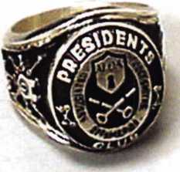

How can I join the President's Club?

You can earn a membership in this prestigious club by recruiting  
just 10 new members for ALOA.

*Any ALOA member may participate.

What do I get?

When you recruit 10 members, you receive a  
handsome blue blazer with a President's Club crest.  
For each additional five members you recruit, you  
receive a lapel pin with gold-filled numbers, indicating,  
your recruiting successes.

You also get the satisifaction of knowing that you are  
helping your association, helping your industry grow,  
and you are helping fellow locksmiths achieve success.

How do I get started?

Mail the form below to the ALOA office for a supply of  
applications (800) 532-ALOA or FAX (214) 827-1810.  
One President's Club credit is awarded for each new  
applicant. Credit is awarded only after the membership  
application is pproved. However, the credit will apply  
for the period in which the application is received.  
Failure to identify yourself as the sponsor on the applica-  
tion form at the time it is submitted to ALOA for process-  
ing will forfeit any credit.

|  |  |
| --- | --- |
|  | Yes! 1 want to join the ALOA President's Club. |
|  | Please rush me applications so 1 can start earning credit toward membership in the club! |
| Nome | |
| Company | |
| Address | |
| City . | ; State Zip |

Mail this form to ALOA • 3003 Live Oak • Dallas, Texas 75204-61 86

Locksmith Licensing—-Why?

by John Griswold, CML

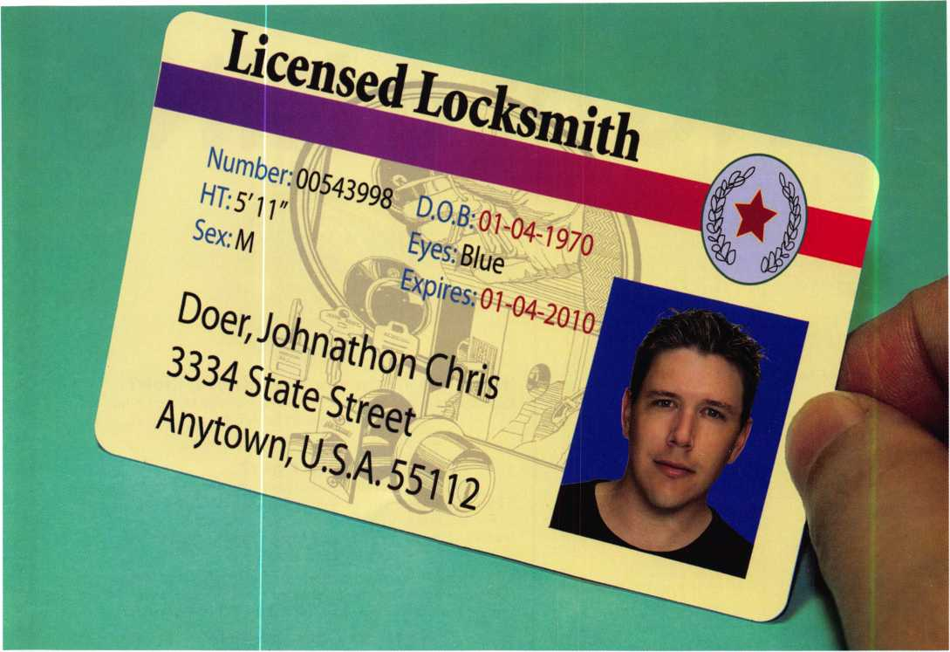

Let me preface this article by saying that I have been a sup­porter of licensing before it became fashionable. I have always thought that the image of the locksmith is so poor, that the simple act of licensing would add prestige and maybe even elevate us to the level of other tradesmen. The general public would look at us the way they did 25 years ago when I started in the industry. They were amazed with the magic we demonstrated when opening a door and thankful when we installed a deadbolt to protect their fam­ilies. But over the years that image has become tarnished. People look at what we do now as simple and overpriced.

A lot of times they are right. Opening a locked door and installing a deadbolt isn’t that difficult given the right tools and the right deadbolt. But knowing the proper way to

open the door, to know which deadbolt to install and how to install it, that makes the difference between a locksmith and a handyman. After long thought, I realized the only way to raise public awareness and the image of the lock­smith is through one locksmith at a time. Licensing alone isn’t going to improve the image, but it won’t hurt.

I have hoped that licensing the locksmith would spur trade schools to add locksmithing to their curriculum. The state could then develop an apprentice program to open a flow of qualified people to fill the growing need for locksmiths nationwide. Without licensing, few see a reason to use a locksmith over a handyman. Other tradesmen see lock- smithing as added revenue for them. Add licensing and your would see fewer non-locksmiths crossing the bound­

Keynotes • March 2005

aries. Licensing would be a big plus for education, and that couldn’t hurt anyone.

Licensing would allow the locksmith to charge more money. I commonly hear this statement from other lock­smiths. It may be true, but it is not a fair representation. How much a locksmith charges should be based on ability, expertise, costs, products sold, and market value. Licensing may allow you to charge more, but should not be seen as an excuse to raise prices.

In most states there are no requirements to open a business and market yourself as a locksmith. In fact, I know lock­smiths with little experience and few tools calling them­selves “Master Locksmiths”. They even use these words in their advertising and on their business cards. Many install improper hardware and hardware that doesn’t meet code or the application. Some do it because they don’t know any better and some just want to make a quick buck. Licensing may not stop this from happening, but it won’t hurt.

I have heard those in favor of licensing say that it will weed out the fringe and fair-weather locksmiths. By imposing a licensing fee, these locksmiths will refuse to pay and choose other work... or they will try to work without a license, forcing licensed locksmiths to report them to the authori­ties. No locksmith wants someone else to get away with something they can’t get away with themselves. Licensing will help here, no doubt.

The most common reason for locksmith licensing is that we must act before others do. This alone presents a strong argument for licensing. Alarm companies and access con­trol specialists are organizing and pushing for legislation to protect what they see as their work. Because the locksmith industry is fragmented and has trouble agreeing on most subjects, we present little opposition to them. They are more organized, better funded, and have long-term plans for their businesses. Locksmiths, on the other hand, are

usually smaller business that barely scrape by each day. “Long term” to a locksmith usually means a week while alarm companies project and plan 2, 3, or 5 years down the road. They know the value of organizing and using the legislature to their advantage. They have an edge over lock­smiths and they know it. The longer we wait, the greater the chance we will lose our market share and income.

I know there will be those who oppose licensing because they don’t want the government getting involved. In a per­fect world, this would be a good argument. But our “dam” has a leak and if it isn’t fixed soon, the flood of legislation pushed by those with opposing agendas will devastate the locksmith industry. Licensing could stop the flood.

I believe all of these points are valid. However, there is a simple reason that I support licensing. It’s right and it makes sense. I have a hard time knowing that the most sensitive, private and valuable things in this country are protected by locks; while the people who install, store keys, and have the ability to bypass those locks, are not licensed or regulated. Where are the safeguards to protect the public security? Most people assume we are licensed or that we are specially trained to do this highly-sensitive work. Those who were amazed at magic of lockpicking in the past are now amazed that there are no formal-training requirements or licensing needed to become a locksmith. I too have been amazed at this.

So what does it all mean? After careful thought, I’ve come to the conclusion that licensing the locksmith has positives and negatives. But after all is said and done, I know that it is the right thing to do.. .for the public and the locksmith. Just as I would not I want an unlicensed doctor or nurse taking charge of my parents’ healthcare, I don’t want an improperly-trained locksmith working on my wife’s car. It just isn’t right.

Keynotes • March 2005

**23**

David Lowell, CML, CMST—

A Lifetime of Dedicated Service

2

0

0

4

**Aloa**



"I have never seen anyone so dedicated to the education and advancement of Locksmiths and the Locksmithing industry. In the 4 years that I have been at ALOA, I have seen him consistently put in 10-hour days and go above and

beyond the call of duty." Gregory Jackson, ALOA IT Operations Manager

0/1

l

I

I

**Lifetime**

**Outstand**'n9

Achieven,en

CML. C»ST / David Lo##”'C* /



Keynotes • March 2005

“David Lowell sets the standard for excellent service and concern for locksmiths and the state of our industry.”

Betty Henderson, Keynotes Editor

DAVID LOWELL, CML,

CMST WINS ALOA’S  
HIGHEST HONOR

The ALOA Lifetime of Outstanding  
Achievement (ALOA) Award recognizes one

of the many deserving people who spend a large  
part of their lifetime helping their colleagues. These people  
should be recognized for their achievements in the fellow-  
ship of locksmithing.

David Lowell, CML, CMST was presented the 2004 ALOA Lifetime of Outstanding Achievement award for his lifetime of contributions through instruction, association service, assisting fellow locksmiths and raising the stan­dards of the locksmith profession.

The award is presented at the ALOA Convention and Security Expo. In a speech by Bob Stafford, CML, David Lowell, CML, CMST was described as calm under pres­sure. “Even though he’s had his ups and downs, he has always handled it in a calm and soothing manner. For years, he has spent long days, nights, holidays, and week­ends defending and fighting for the rights of locksmiths. “

David modestly approached Mr. Stafford after receiving the A.L.O.A. award to to thank him for presenting it. David said, “I had no idea I was the one you were talking about, when you were up there on the podium, because I never dreamed I would ever receive such an honor.

A HISTORY  
OF DEDICATION

David Lowell’s first exposure to lock-

smithing came as a result of baseball. He  
and several friends played little league baseball

together growing up and one of his friend’s parents  
owned a locksmith & lawnmower repair shop in Phoenix,  
Arizona. The boys would go over to the shop before or  
after practice and while his dad or brother was working on  
locksmithing or repairing lawnmower engines, the boys  
would test out the “tote gotes” (little motorized scooters)  
that were a part of the lawnmower inventory. As time went  
on David joined the United States Navy (Feb 1967-Nov  
1970). When he got out he went to work as a paramedic  
and went to school. He also continued to work at Phoenix  
Lock 6c Key on his days off. (the lawnmowers and tote  
gotes were no longer there, just locksmithing).

He started working full time as a locksmith in 1972 and eventually David progressed from locksmith to manager to owner of Phoenix Lock & Key in 1979 (later named Phoenix Security Centers). He also concurrently owned and operated two additional locksmith businesses in the Greater Phoenix Arizona until 2002.

David has been an ALOA member since 1980. During this time he served as President of the Professional Associated Locksmiths of Arizona (PAL), vice chairman and co­founder of the Grand Canyon Chapter of ALOA and

“David is a most-dedicated employee and everything he does for ALOA is from his heart.”

Jo Anne T. Mims ALOA/SAVTA Convention/Meetings Manager



Keynotes • March 2005

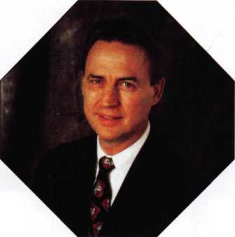

ABOUT THE A.L.O.A.

This award recognizes one of the many deserving people who spend a large part of their lifetime helping their colleagues. These people should be recognized for their achievements in the fellowship of lock- smithing.

AWARD RULES

The ALOA Lifetime of Outstanding Achievement Award will be presented under the following rules:

1. Awarded to a living person who has shown a lifetime of outstanding achieve­ment in, and support for, the locksmith industry. Recipient must have made out­standing contributions to the industry through education, association service and public relations.
2. Given only once a year.
3. Presented at the ALOA Membership Meeting by the ALOA President.
4. Does not have to be awarded if a suit­able applicant cannot be found.
5. Can be received only once in a lifetime.
6. Cannot be awarded posthumously unless recipient has died after selection by committee.
7. Recipient may not be a seated member of the ALOA Board of Directors or a non-voting member of the Board.
8. Recipient must be currently active in the industry, but may be retired from active work as long as they are showing active support of the industry.
9. The award committee may receive sug­gestions for the recipient, but will not be bounded by those suggestions.

1 0. The recipient is to be selected by the most recent available past three recipients.

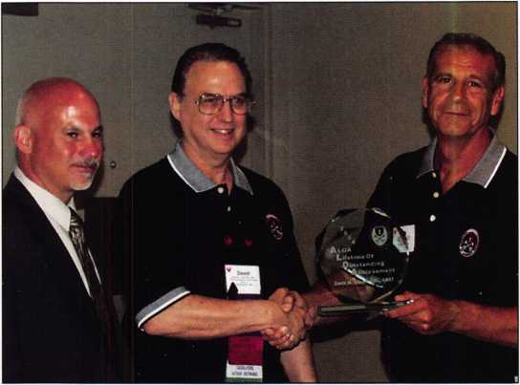

member of the ALOA Board of Directors from 1988-1997.

He has held the offices of member-at-large, director, Southwest Vice President and President (1995-1997).

David has been very involved in the PRP from the time that the first test was given in June 1985 where he passed the RL exam. After becoming one of the first 20 CPL’s in September of 1985, he became one of the first 20 CML’s in August 1986. He served on the PRP Committee beginning in 1988 and was appointed Chairman of the Proficiency Registration Committee in 1991. He has been actively involved with ALOAs education and certification programs ever since. Currently, David is the Associate Executive Director of ALOA. He completed his six-year commitment on the ALOA Board of Trustees in July 2003. He was pre­sented the ALOA Presidents award in 2003 in recognition of his outstanding contributions to ALOA and the lock­smith industry.



Keynotes • March 2005

R E AC HI N G NEW H El G H TS

Albuquerque, New Mexico

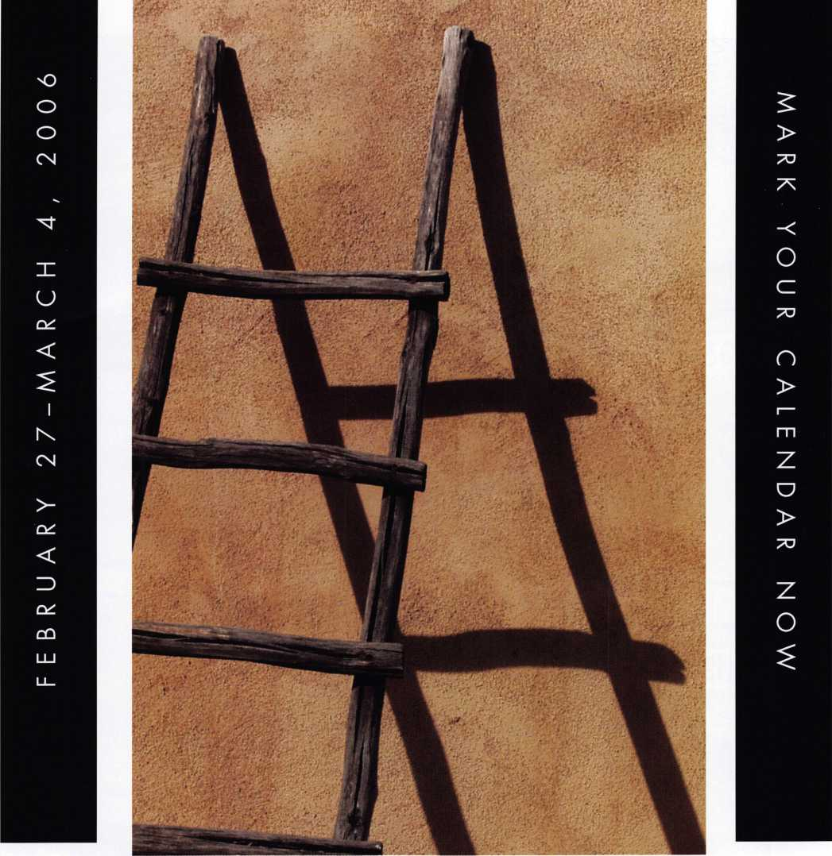

When it comes to learning about the  
latest in safes and vaults, time is of the  
essence. SAFETECH 2006 features an  
all-new menu of classes, covering every  
safe topic on the globe. Don't miss out!

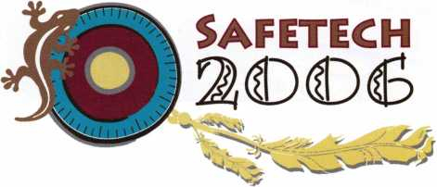

Servicing Bank Equipment

by Brian Smith

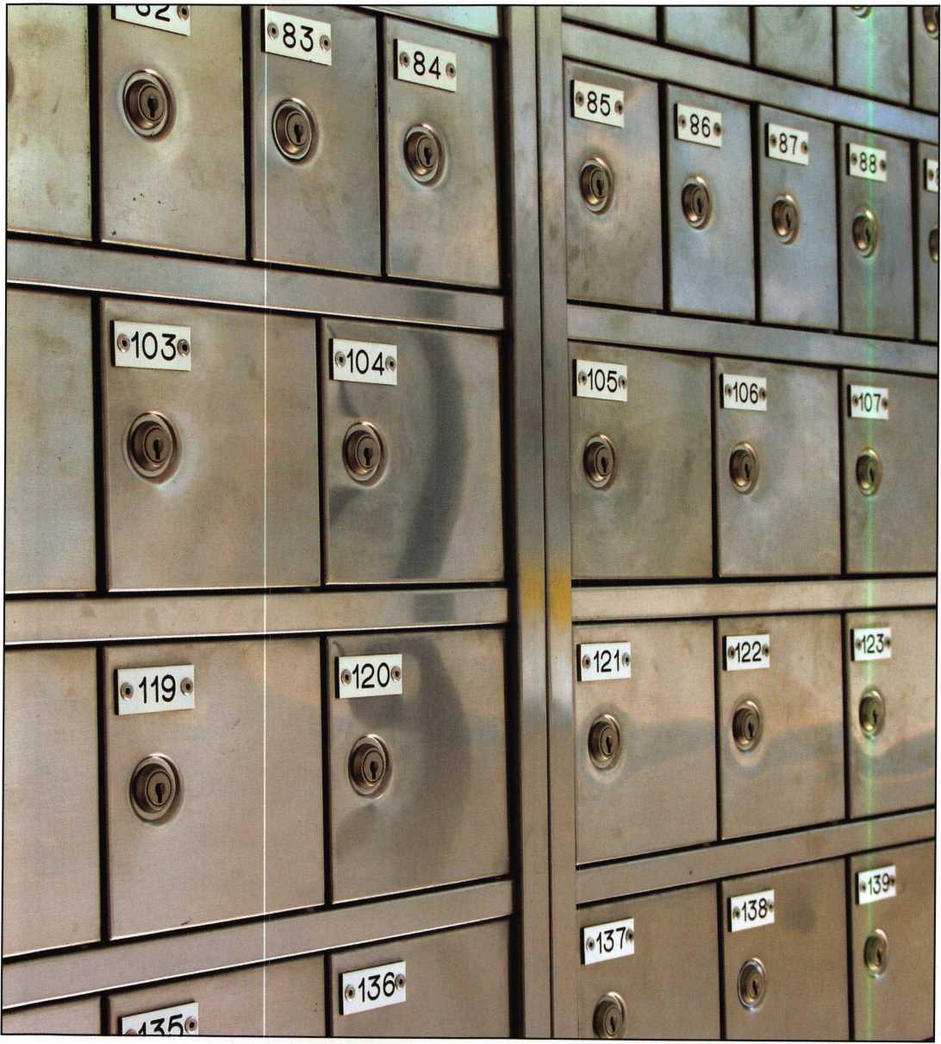

Keynotes • March 2005

In dealing with bank equipment, it is hard to avoid work­ing with lever tumbler locks. They are found on; service cover doors, day gates on the back side of antique vault doors, mounted on the inner doors on many of the old lug door safes, securing teller compartments on the inside of bank cash lockers and among other places, you will find them by the thousands on safe deposit box doors. The two major differences in lever tumbler locks are; the number of keys used to operate them (one or two), and how the locks are changed for rekeying (fixed lever, changeable lever and changeable fence) the last two allow for changing the com­bination of the lock mechanically rather than disassem­bling the lock to physically changing or replace the levers. The methods of changing these are many, so I will concen­trate on the basic single key, fixed lever type first.

Making new keys for lever tumbler locks is done most easi­ly by code, but when codes and depth/space data are not available, the “smoking” method comes next. The process is one in which the working edge of the new key blank is placed over the flame of a candle (see “smoking the blank” fig 1). The black carbon from the smoke is transferred to the blank, so once the blank is placed in the lock and turned as if to open it, the carbon will be rubbed away to show shiny spots on the blanks’ surface. The effect is simi­lar to the filed edge method used by some when impres- sioning pin tumbler locks. The smoke helps to eliminate the risk of over-cutting because the markings are easier to see. In the absence of a candle, a lighter or black perma­nent marker can be used. The marker usually comes off a bit too easy though, leaving false marks. Once the contact

THE HINGE DOCTOR

**by GKL Products**

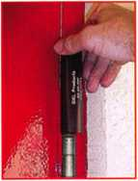

**HA1 For  
Standard**

**Commercial**

**4-1/2" x 4-1/2"**

**Butt Hinges**

**HA2**

*"The HULK*

**For Residential Hinges**

COMING IN  
SEPTEMBER

**HA3**

**For Ball- Bearing**

**Commercial Hinges**

**The Hinge Doctor is a great way to repair those sagging metal  
doors. Slip the tool over the hinge and open the door an inch**

**or two past the point where the tool binds against the  
hinge, remove the tool and check the door,**

**which should now be working properly.  
If you're a locksmith these tools**

**will turn a profit the 1st time you**

**use them!  
Uses - schools, hospitals,**

**commercial buildings, storefronts**

**with butt hinges, office doors, new**

**construction, door alignment, sagging**

**doors, jail cells, anywhere there are  
commercial grade hinges.**

**HA4**

**For Prison**

**& Institutional**

**Hinges &**

**Spring Hinges**

US Patent

#6450003

**[www.hingedoctor.com](http://www.hingedoctor.com)**

800-924-5397

Over

10,000

Satisfied

Customers



Keynotes • March 2005

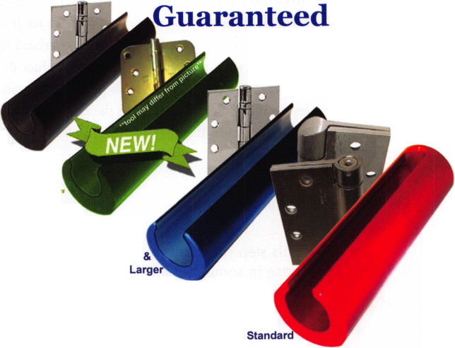

points are marked on the key blank, remove it from the lock. You can read several things from the marks. If the blank does not have a “throat cut” for the “throat ward”, as is often the case when keying up old locks with a generic blank, that’s the first mark that will show.

A caution before continuing: If the blank you choose is not designated specifically for the lock being keyed, the blank may fit the “guide”, but the tip of the blank may not seat all the way into the “foot” as it should. If you are matching a blank to a lock for the first time, it is good practice to remove the cover first to ensure that this fit is correct.

There is a subtle difference in some lock designs that is most pronounced in, but not exclusive to Herring Hall Marvin safe deposit locks. The end of the key blank tip rests on the foot itself (as shown in “key blank tip” fig. 2). The majority of locks are different in that the tip of the blank rests or protrudes through the bottom of the foot and or the case.

Clamp the blank in a duplicating key machine. With a thin (.045”) side milling slotter blade, make the throat cut first. You will know you have cut enough when the blank turns freely but not loosely. All of the levers will be lifted above or aligned with the bolt stop as you see them through the inspection hole in the cover (see “viewing the levers” fig 3). If it is visible that any levers are below the fence, through the inspection hole with the blank in posi­tion, there could be a problem. Either the blank is not as wide as it should be, or there is a problem with the levers.

In either case you will have to correct the problem before you proceed, either by selecting a wider key blank or repairing the levers. Don’t hesitate to re-smoke the blank for the next step. Take the blackened blank and turn it again several times in the lock to pick up markings from the levers. With a scribe or other sharp marking tool, scratch a line between each lever mark so you can tell where the divisions between the levers are (see “reading the marks” fig. 4). Take the newly marked blank to the key machine and cut away at the bright spots between the lines, one at a time starting with the one closest to your view. Keep in mind that the marks are not always perfect and easy to read. If you use what you should already know about these locks, that there is a definite number of lever tumblers, and that in general, all of the levers have a com­mon thickness, you will be able to make an educated guess when you need to, to find where the divisions between the levers are. One at a time, beginning with the one closest to you as you look through the inspection hole in the lock cover, cut just a bit at a time and check your progress fre­quently. There’s no shame in not removing enough metal the first cut or two. Too much, turns your key blank investment into brass scrap. The further you progress through the levers, the harder it can be to see if your levers are on the mark. Get plenty of bright overhead light and be sure of what you see. The finished product should look like fig. 5 (“lock aligned”). This process is repeated for each lever until each is aligned with the fence. At this point the key should turn further which will pull the bolt in, unlock-

This step rests on the foot itself

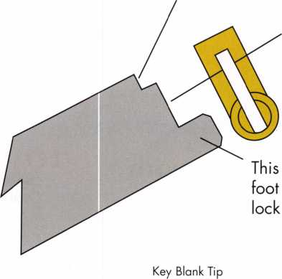

This step rides against the case in some, but it is held above it in this type

step passes through the and usually through the case

Keynotes • March 2005

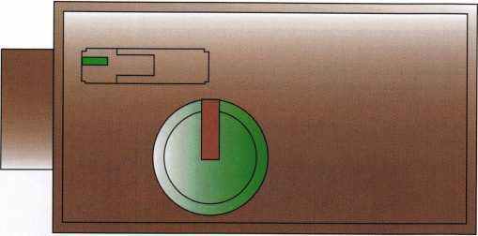

Lock Aligned

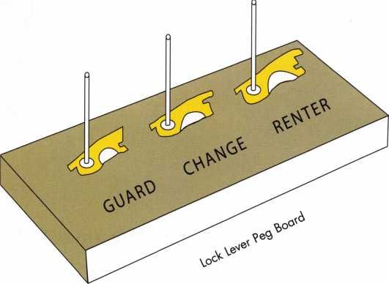

ing the lock. That is if the lock is clean and in good work­ing condition.

Problems in re-keying this type of lock can be many, most­ly simple, but often unpredictable. One turn of the key might be successful; sometimes even ten turns when the lock is not mounted on the door, but suddenly, once mounted and locked, it won’t work for various reasons.

The compression of the unit may miss-align the levers and render the key useless. Make it a matter of habit to check the following details, before making keys:

1. Open up the lock and inspect the inside for dirt, excess grease or oil, or any of that nasty old graphite.
2. Pull out each part placing them on a clean surface.
3. Stack the levers on top of each other in the order they were removed. I use a peg board I made for this pur­pose. It has steel pins pressed into the board over which the pivot hole of the lock levers can be placed so they remain stacked. This way they can be kept in the right order even if they are bumped during the job (see “lock lever peg board” fig. 6).
4. Clean all of the parts as necessary with mineral spirits or a similar solvent.
5. Inspect the post for wear or loose cams.
6. Inspect the levers for flatness, wear, holes from previ­ous drilling, and burrs.
7. Don’t forget to check the locking bolt for flatness and free movement in and out of the lock body. One of the most difficult sticking points to detect is bent lock­ing bolts. This can be caused by attempts to close the door after the keys have been removed or by pullers if the door was forced open after a lockout.
8. As you replace parts, be sure they fit together as they should. There is no guarantee that you received the lock in proper working order. The only way to be sure the lock came with all the parts in the right place is to look. If you have any doubts, refer to a lock manual.

There are so many models, revisions and their clones, that unless you are very careful to keep parts separated, confu­sion is highly likely. One example, the only obvious differ­ence between levers in the S&G 4400 series and the ILCO A40 series is the size of the posthole. Another example is the varied thicknesses of levers and spacers in some of the Diebold locks. If there is any doubt of the locks’ integrity, do whatever it takes to assure yourself and the customer of reliable service. A good locksmith keeps his eyes trained on these details.

Keynotes • March 2005

**31**

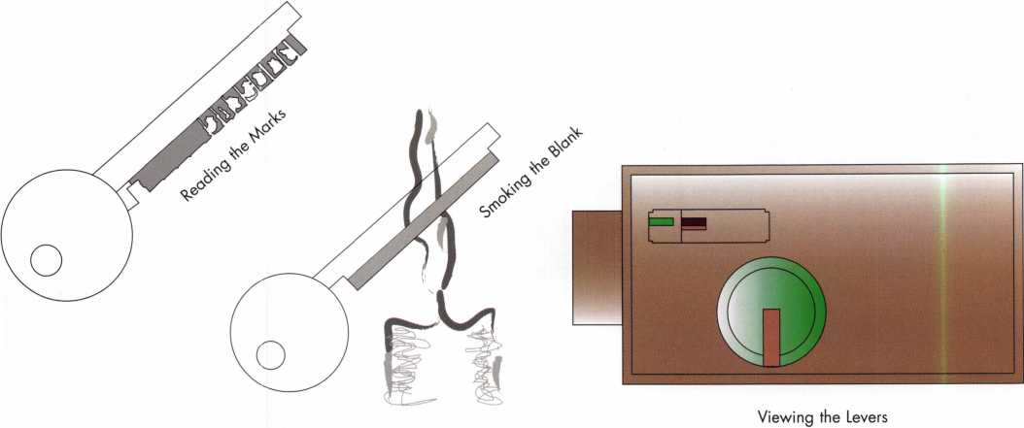

Technical Editors note: Here are Safe Deposit Lock Terms from the ALOA Locksmith Glossary. (Those marked with * have not been approved by the LIST Council.)

changeable lever

n. a lever tumbler typically made in two or more pieces which can be variably positioned with each other to change the effective location of the gate

* changeable fence

n. a group of projections on a lock bolt that can be moved to change the effective location of the fence which prevents movement of the bolt unless it can enter gates of properly aligned tumblers.

fence

n. 1. a projection on a lock bolt which prevents movement of the bolt unless it can enter gates of properly aligned tumblers, 2. any locking element other than a sidebar or shackle designed to enter a tumblers gate, 3. a projection on the lever in a combination lock that prevents the lever from engaging the drive cam until the proper combination is entered, see also “sidebar”

foot

n. the cam portion of the trunnion assembly in some lever tumbler locks

gate

n. a notch cut into the edge of a tumbler to accept a fence or sidebar

guide

n. 1. that part of a key machine which follows the cuts of a pattern key or template during duplication, 2. that part of a flat key lever lock which connects the nose to the foot and supports the key blade

lever tumbler

n. a flat, spring-loaded tumbler which usually pivots on a post. It contains a gate which must be aligned with a fence to allow movement of the bolt.

throat cut

n. the cut made into a key to bypass a throat ward

throat ward

n. an obstruction formed in a lock’s case or horn at the point of key entry, which prevents key rotation

trunnion

n. the part of a lever lock that accepts the key and stabi­lizes it, typically a single piece or an assembly consisting of some combination of a nose, guide and foot

**32**

Keynotes • March 2005

**Receive up to**

**25% off**

**list price!**

Just a Few

of Our Titles •••

Learn About Basic Electricity 29.95

Spacing and Depths, vol 1 19.95

Spacing and Depths, vol 2 19.95

Filing for Dollars 29.95

Antique Padlocks 29.95

VATS Made Simple (Revised) 29.95

Guide to Transponders 79.00

2000 Transponder Update 45.00

Bread & Butter 85.00

Locks and Lockmakers of America 19.95

Learn About Electronic Locking Devices 29.95

The Best of Locksmithing, vol 1 19.95

Logical Lock Diagnostics 29.99

How to Pick Lever Locks 19.95

Fundamentals of Master Keying 55.00

Guide to Electronic Locksmithing 39.95

Security Solutions Locksmith Marketing Program 89.95

The Ultimate Techtips Collection 39.95

PRP Resource Guide 25.00

Locksmithing from Apprentice

to Master 27.00

Wafer Lock Reading 19.95

Door Lock Encyclopedia 39.95

Lock Repair Manual 14.95

Interchangeable Core Cylinders 34.95

Picking & Impressioning 45.00

The Lure of the Lock 29.95

High Security Safes, vol 1 175.00

High Security Safes, vol 2 175.00

Safeman's Guide, vol 13 9.95

Safe Deposit Depth and Space Manual 99.00

Safe Technician's Reference Manual 155.00

Gun Safes 110.00

Modern Safe Opening 59.95

Dave McOmie on Vault Doors, vol 1, Bank Vaults 110.00

Dave McOmie on Vault Doors, vol 2, Fire and Plate Vaults 1 10.00

Modern Safe Locks 95.00

Drilling Safes 95.00

Safe Deposit Box Service 39.95

Foreign Car Impressioning Book 29.95

Impressioning Ford and GM Side Bar Locks 29.95

Automotive Lock Servicing Update #1: GM 10-Cut Locks 29.95

Automotive Lock Servicing Update #2: GM 10-Cut Locks 29.95

Automotive Lock Servicing Update #3: GM 8-Cut Locks 29.95

GM Locks: Perfect for the Beginning Locksmith! 29.95

Ford Locks: Pin Tumbler and Ten-Cut Systems 29.95

Chrysler Pin Tumbler Locks 29.95

Chrysler Double-Bitted Locks 29.95

Toyota Split-Tumbler Locks 29.95

Basic Door Panel Servicing 29.95

Advanced Door Panel Servicing 29.95

Motorcycles on CD 99.00

The Guide to Motorcycles 99.00

Japanese High Security Auto Servicing 29.95

Revised GM Steering Column Course 1 15.00

Foreign & Domestic Auto Service 69.95

Auto Lock Service 14.95

The Sieveking Auto Key Guide & Illustrated Cross Reference 27.00

Servicing Interchangeable Cores —Sargent 25.00

Servicing interchangeable Cores—Arrow, Best,

Eagle, Falcon, and Lockwood 25.00

The Ultimate CCTV Program on CD Rom 595.00

**Visit the new-and-intproved ALOA Store to view more available titles.  
Place your order online or by phone today!  
[www.aloa.org](http://www.aloa.org) • (214) 827-1701 • Please allow 3-4 weeks for delivery.**

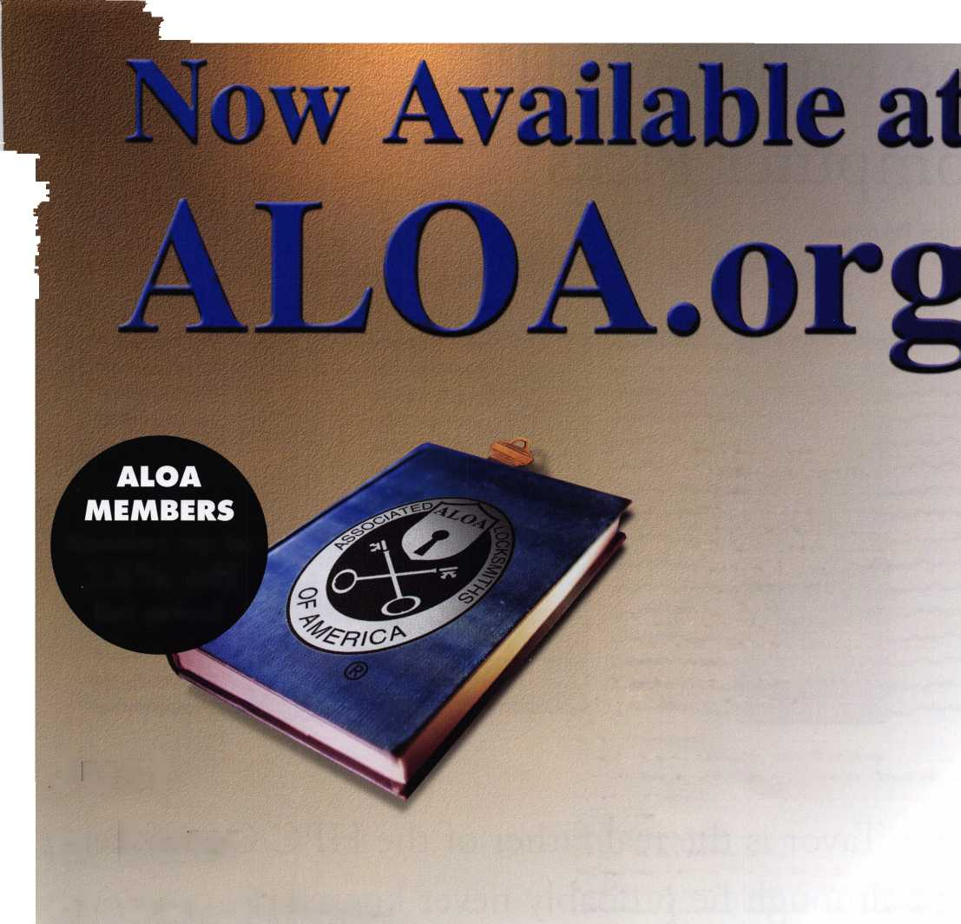

The Father of HPC Computer Picks

**by** Jacques Peyronnet

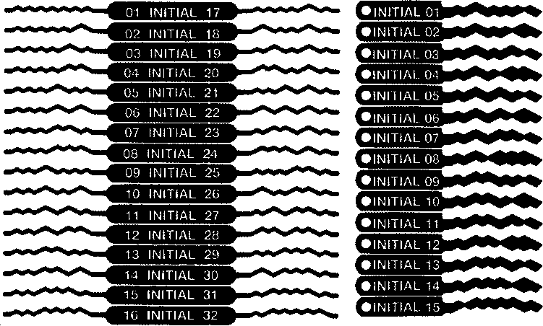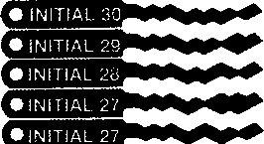

> INITIAL 24

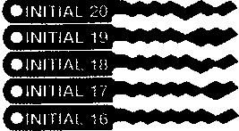

Moshe Tavor is the real father of the HPC Computer picks, although he probably never knew it.

**34**

Keynotes • March 2005

I truly enjoyed reading Eric Costleys 3 articles in **Keynotes** about lock picking (“Whats in your Pickset?” 2004). I admire the author s vast knowledge, the fluency of his pen and the quality of his humour.

I am a French citizen, who started in the lock business long ago at Fichet. I then moved to Sargent & Greenleaf andnran their European subsidiary for 14 years, then start­ed my own company, INITIAL as their exclusive distribu­tor for France. Lock picking was always one of my pas­sions. I also distribute picks and teach lockpicking.

The authors comments in the December 2004 issue of **Keynotes** about the HPC computer picks brought back old memories and I cannot resist telling the true story and ori­gin of these picks. I am a firm believer that sharing knowl­edge is necessary for survival.

Back in the late 60s I met a fantastic lock picker by the name of Moshe Tavor. He was the "James Bond" of Israel and we exchanged tricks on lock opening. He had a nice set of picks that he had designed himself. Rather than rakes, he called them "waves". There were 9 different waves supposed to summarize most of all possible combi­nations in standard 5-pin cylinders. He let me photocopy his set. I made my own duplicate and found them useful.

Some 10 years later, in the mid 70s, I showed them to Nick Gartner. At the time, Nick was working for Sargent & Greenleaf and had not yet founded LaGard. He took a photocopy of that set and to my surprise they soon appeared in the HPC Catalog as the Computer Picks.

They were the exact waves designed by Moshe but, strangely, enlarged to a scale that made them too big for their purpose. I suppose that when Nick took that photo­copy he pressed the zoom button either inadvertently or on purpose to get a better view.

This may explain the frustrating results Eric Costley had in trying them. If you have the patience, duplicate the HPC computer picks, reducing them to 70% on the photocopy. You will find that they work much better.

Moshe explained that he designed them to solve "mush­room" pin problems. Because the wave does not pick the pins but instead replicates the actual key cuts, all pins are lined up simultaneously and mushrooms don't bind. I knew that Moshe had used his knowledge of locks and keys, plus his imagination-but definitely not a computer, to design these waves.

I decided to work further on his idea. I compiled spacings and depth of over 100 makes of cylinders, including some 7-pin cylinders as specified in Scandinavia. Boiling all this down produced what I called the "Super Picks" and "Magic Keys". The photo shows what they are: 16 double­head picks and 30 "magic keys”. The double picks produce 32 different waves. Each wave can be tried up side down which makes 64 key patterns plus 60. With the "magic keys", a total of 124 are possible. As a wave moves in and out and up and down in the lock, every minute displace­ment generates a new combination

They are used with any tension wrench but with very light tension to let the pins "surf on the waves" without bind­ing. The key to success is faith. You must BELIEVE that the real key to that lock is hidden somewhere in these waves. Then it's all luck. You could hit the right wave in the right position on your first few trials or on the very last one. Even so, scanning all positions of a vawe in the keyway takes only 5 seconds. With the worst of luck, it takes 10 minutes. Once you have the right wave in the right position, you don't need a plug spinner to pick more than once.

Over the years Super Picks have become the favorites of many European locksmiths. In the USA, Mark Bates sells a few for us—probably to locksmiths least allergic to egotism.

Anyhow, to set the record straight, Moshe Tavor started it all and he is the real father of the HPC Computer picks, although he probably never knew it.

**35**

Keynotes • March 2005

Classifieds



EMPLOYMENT

LOCKSMITH FOR HIRE

New York Licensed Locksmith with 25+ years exp. in running and maintaining an In-house Locksmith shop is looking for a new position. Experienced in Masterkeying, Removable core sys­tems, Simplex combination locks, Lock- Alarm hardware, desk and cabinet hardware, door-closers, etc. This ALOA and Nyail (NY Assoc. In-house Locksmiths) member is available for work immediately. Resume is available upon request. Call or Email Richard Sommers at (914) 734-2303

[Bestkey@Optonline.net](mailto:Bestkey@Optonline.net).

LOCKSMITH TECHNICIAN WANTED

In-house locksmith with experience road and shop work for commercial, safe, and access control service.

Salary plus benefits. See website or call for details 71 3-755-5906 for details. Apply in-person 1310 Prairie 2nd floor, Houston, Texas, 77002

<http://www.co.harris.tx.us/hrrm/Empl>

oyment.htm

SEEKING POSITION:

Locksmith/Key System Specialist/Physical Security Specialist/Sales Engineer/Project Manager. I am seeking a position that will utilize my many years of commer­cial locksmithing. I am experienced in commercial installations, design and lay out of large master key systems, access control, CCTV. Have been an instructor to commercial accounts on

basic locksmithing, master key systems, access control systems, and CCTV sys­tems. I started my locksmithing career in a 4 year apprenticeship program and worked my way up to sales engi­neer/project manager in mechanical locking hardware, electronic locking hardware, access control and CCTV. I hold a current North Carolina lock­smith license. I am a past Chapter Chairman of the Greater Charlotte Chapter 65 of the American Society for Industrial Security and a 3 time United States Patent holder for the security industry. Upon request a full resume will be provided. Please give company name, location, contact name, and phone number or E-mail address, Make all Inquires to 704/537-9161 or E-mail [RCHARREB5@AOL.COM](mailto:RCHARREB5@AOL.COM)

MANAGER OF TRAINING

($70-80 Base plus bonus, great bene­fits!) Reports to the Director of HR, dot­ted line to the VP of Sales and Operations. High energy performer who can create, develop, implement, and manage national technical train­ing programs. This person will set up Training from "ground zero" with two main initial priorities: 1) to set up a national program for over 5000 Hardware stores across the US need­ing technical training with advance Key Cutting and leading edge Locksmithing skills. These are privately held stores that have the company's key cutting machines in their stores and need to be trained. 2) To set up a comprehensive training program for the new start up Kiosk Division now with 52 locations in a major DIY retail­

er in New Jersey. This will include an incremental training series to grow people from an "apprentice" type pro­gram to advanced "Transponder tech­nology" (computer chipped keys) in a relatively short period of time. This division is expecting national growth and expanded market share. The over­all vision for training will be the devel­opment and growth of highly trained, customer focused employees. Heavy project and vendor management. For immediate consideration, please con­tact: Carla McBride, CPC, Valiant Enterprises, 216-261-7210 or email

[greatrecruiters@earthlink.net](mailto:greatrecruiters@earthlink.net).

WANTED TO BUY/SELL

EQUIPMENT FOR SALE

Various old locksets (e.g., deadbolts with TT" throws) and especially old out-of-production key blanks, sectional or otherwise (such as the Yale &

Towne "Omega" offset "X" and "Z" series & the Corbin "R" series bit keys). Also of note is a behemoth llco bit & barrel duplicating machine where the double-jaw, single tower can be rotated to make ward cuts & an R.C. Allen pull handle tabulating cash register. Time is of the essence as my building will be torn down in a month and most of this old stock will not be moving with me unless it is spo­ken for. I would also be interested in hearing from anyone who could pick

up & provide at least a temporary home for these old soldiers before they're buried under tons of rubble. Any inquiries or "wish lists" can be sent to me, Tom Steger, at [lockdoc215@hotmail.com](mailto:lockdoc215@hotmail.com).

EQUIPMENT FOR SALE

Mounted Locknetic Sample For Sale: CM5190- MGKx626 mounted on a oak mount asking $100 Primus Demo Kit[/b] New asking $75.00 [kishjohn@comcast.net](mailto:kishjohn@comcast.net) Telephone is 412-400-5900

EQUIPMENT FOR SALE

Intellikey items many 1000 and 4000 series items: keys, sales kits much more.Stanley prime painted hinges, CB,F series many sizes If interested please email me at [ARCHHDW@YAHOO.COM](mailto:ARCHHDW@YAHOO.COM)

WELL ESTABLISHED

Key and Lock business. Good return on investment. $275,000. Call Mark Gillispie at 503-812-2615.

WHOLESALE SAFE DEPOSIT LOCKS

Diebold, Herring Hall Marvin, llco, LeFebure, Mosler, Precision, S&G, Security Corp, Yale. Now available Safe Deposit Boxes Sections, Doors, Hinges and Bond Tins. Vault Doors, Safes, Night Depositories, Vault Lockers and One Inch Plate Steel are also stocked items. Call WBI (954)484- 2404 or [Sales@WBI.US](mailto:Sales@WBI.US).

FOR SALE

DEXTER Deadbolts for sale. 4009 4109 4209 Over 250 for sale. Finish: 3 & 7A. Would rather not ship, however can be neg. Call 734-668-6863 M-F 08:30 am - 05:00 pm EST. Vogel's Lock & Safe Ask for Robert.

BUSINESS FOR SALE

Lock and safe company serving south eastern Pennsylvania and sourthern New Jersey. Fully stocked van with G.P.S. navigation system, custom lighting package, computer, ITL and HPC code machines, tools, inventory. Great area and cus­tomer base. Will train if necessary and help through owner transition. Call 800-648-9962.

FOR SALE

Kaba 1550-S PowerLever door lock, black body/chrome lever w/cylinder. This is an extra that we don't need; absolutely brand new, never removed from original packaging. List is $660. Sell for $300, which includes shipping anywhere in the contiguous U.S. Please email [selectlocks@aol.com](mailto:selectlocks@aol.com). Or write to George Kenney, 696 San Ramon Valley Blvd., Suite 221, Danville, CA 94526.

PRICE REDUCED!!

Opportunity of a Lifetime!! 28 year established, well equipped mobile lock shop. Inventory, tools, truck and monthly alarm income. Approximately $150,000 wholesale cost. Will sacrifice for quick sale for only $91,000!!! (Check E-Bay = DENVER LOCKSMITH) or Call: 303-795-7600 or E-mail: stan [1926@quest.net](mailto:1926@quest.net).

Classified Advertising Policy

Classified advertising space is provided free of charge to ALOA members and for a fee of $2.00 per word**,** $40.00 minimum for non members. Classified ads may be used to advertise used mer­chandise and overstocked items for sale, "wanted to buy" items**,** business opportunities**,** employment opportunities/positions wanted and the like. Members or non members wishing to advertise services or new merchandise for sale may pur­chase a "Commercial Classified Ad" for a fee of $4.00 per word with a minimum of $100.00.

Each ad will run for two issues. For blind boxes there is a $10.00 charge for members and non members. All ads must be submitted in writing to the Advertising Sales Department via fax at 817- 645-7599 or through an email to [adsales@aloa.org](mailto:adsales@aloa.org) by the fifteenth of the month two months prior to issue date. ALOA reserves the right to refuse any classified advertisement that it deems inappropriate according to the stated pur­pose of the classified advertising section.

|  |  |  |  |  |
| --- | --- | --- | --- | --- |
| Ai | * -J  Q  c/>  CO | o c | i a 1 | ■ e |
|  | m | e m b | e r s |  |

Distributor

**1 st In Hardware, Inc.**

Phone: 866-397-9900 Fax: 866-646-0045 www. 1 stinhardware.com

**ADI Inc.**

Phone: 631-692-1000 Fax: 631-692-3011

**Accredited Lock Supply Co.**

Phone: 800-652-2835 Fax: 201-865-0030 [www.acclock.com](http://www.acclock.com)

**Ace Lock & Security Supply**

Phone: 800-223-5625 Fax: 908-688-2442 [www.acelock.com](http://www.acelock.com)

**Andrews Wholesale Lock Supply**

Phone: 717-272-7422 Fax: 717-274-8659 [www.andrewslock.com](http://www.andrewslock.com)

**Boyle & Chase Inc.**

Phone: 800-325-2530 Fax: 800-205-3500 [www.boyleandchase.com](http://www.boyleandchase.com)

**Chinrose International**

Phone: 503-357-7553 Fax: 503-357-5522 [www.chinrose.com](http://www.chinrose.com)

**Clark Security Products**

Phone: 888-784-1311 Fax: 619-718-7333 [www.clarksecurity.com](http://www.clarksecurity.com)

**Cook's Building Specialties**

Phone: 505-883-5701 Fax: 505-883-5704

**Dire's Lock & Key Company**

Phone: 303-294-0176 Fax: 303-294-0198

**Direct Security Supply, Inc.**

Phone: 800-252-5757 Fax: 800-452-8600

**Discount Key Machines.Com/Busch**

Phone: 800-332-8724 Fax: 407-363-4666

**Doyle Security Products**

Phone: 800-333-6953 Fax: 612-521-0166 [www.doylesecurity.com](http://www.doylesecurity.com)

**Dugmore and Duncan, Inc.**

Phone: 888-384-6673 Fax: 888-329-3846

**E. L. Reinhardt Co., Inc.**

Phone: 800-328-1311 Fax: 651-481-0166 [www.elreinhardt.com](http://www.elreinhardt.com)

**Ewert Wholesale Hardware**

Phone: 800-451-0200 Fax: 708-597-0881

**Fairway Supply, Inc.**

Phone: 214-350-0021 Fax: 214-352-4299 www. fa i rwaysu pply. com

**Foley-Belsaw Company**

Phone: 800-821-3452 Fax: 816-483-5010 [www.foley-belsaw.com](http://www.foley-belsaw.com)

**Fried Brothers Inc.**

Phone: 800-523-2924 Fax: 215-592-1255 [www.fbisecurity.com](http://www.fbisecurity.com)

**Hans Johnsen Company**

Phone: 214-879-1550 Fax: 214-879-1530

**Hardware Agencies, Ltd.**

Phone:416-462-1921

[www.hardwareagencies.com](http://www.hardwareagencies.com)

**IDN Incorporated**

Phone: 817-421-5470 Fax: 817-421-5468 [www.idn-inc.com](http://www.idn-inc.com)

**Instant Hardware Delivery, Inc**

Phone: 800-355-1107 Fax: 800-663-8518

**Intermountain Lock & Supply**

Phone: 800-453-5386 Fax: 801-485-7205 [www.intermountainlock.com](http://www.intermountainlock.com)

**International Electronics, Inc**

Phone: 800-343-9502 Fax: 617-821-4443

**Jo Van Distributors**

Phone: 416-752-7249 Fax: 416-752-7282 www. jo va nlock.com

**Lockmasters, Inc.**

Phone: 859-885-6041 Fax: 859-885-7093 [www.lockmasters.com](http://www.lockmasters.com)

**Locks Company**

Phone: 800-288-0801 Fax: 305-949-3619

**Locksmith Ledger International**

Phone: 770-886-0800 Fax: 770-889-7703 [www.lledger.com](http://www.lledger.com)



**M. Zion Company**

Phone: 212-349-8677 Fax: 212-964-0495 [www.mzion.com](http://www.mzion.com)

**McDonald Dash Locksmith Supply**

Phone: 800-238-7541 Fax: 901-366-0005 [www.mcdonalddash.com](http://www.mcdonalddash.com)

**Monaco Lock Co.**

Phone: 800-526-6094 Fax: 800-845-5625 [www.monacolock.com](http://www.monacolock.com)

**Omaha Wholesale Hardware**

Phone: 800-238-4566 Fax: 402-444-1664 [www.omahawh.com](http://www.omahawh.com)

**RA-Lock Company**

Phone: 972-775-6301 Fax: 972-775-6316 [www.ralock.com](http://www.ralock.com)

**Security Distributors Inc**

Phone: 800-333-6953 Fax: 612-524-0166

**Security House**

Phone: 905-669-5300 Fax: 905-660-6313 [www.securityhouselock.com](http://www.securityhouselock.com)

**Security Lock Distributors**

Phone: 800-847-5625

Fax: 800-878-6400

[www.securitylockdistributors.com](http://www.securitylockdistributors.com)

**Shin-An Enterprise Inc.**

Phone: 718-225-5380 Fax: 718-819-0723

**Southern Lock and Supply Co.**

Phone: 727-541-5536 Fax: 727-544-8278 [www.southernlock.com](http://www.southernlock.com)

**Stone & Berg Wholesale**

Phone: 800-225-7405 Fax: 800-535-5625

**The Locksmith Store Inc.**

Phone: 847-364-5111 Fax: 847-364-5125 [www.locksmithstore.com](http://www.locksmithstore.com)

**Timemaster Inc.**

Phone: 859-259-1878 Fax: 859-255-0298 [www.time-master.com](http://www.time-master.com)

**Top Notch Distributors, Inc.**

Phone: 800-233-4210 Fax: 800-854-4146 [www.topnotch.bz](http://www.topnotch.bz)

**Turn 10 Wholesale**

Phone: 800-848-9790 Fax: 800-391-4553

**U.S. Lock Corp.**

Phone: 800-925-5000 Fax: 800-338-5625 [www.uslock.com](http://www.uslock.com)

**Wilson Safe Company**

Phone: 215-492-7100 Fax: 215-492-7104 [www.wilsonsafe.com](http://www.wilsonsafe.com)

Manufacturer

**A & B Safe Corporation**

Phone: 800-253-1267 Fax: 856-863-1208 [www.a-bsafecorp.com](http://www.a-bsafecorp.com)

**ABUS Lock Company**

Phone: 800-352-2287 Fax: 602-516-9934 [www.abus.com](http://www.abus.com)

**Access Security Products Ltd.**

Phone: 905-337-7874 Fax: 905-337-7873 [www.access-safe.com](http://www.access-safe.com)

**Adams Rite Mfg Company**

Phone: 800-872-3267 Fax: 800-232-7329 [www.adamsrite.com](http://www.adamsrite.com)

**Adesco Safe Mfg. Company**

Phone: 800-694-9340 Fax: 562-408-6427 [www.adesco.com](http://www.adesco.com)

**Adrian Steel Company**

Phone: 800-677-2726 Fax: 517-265-5834 [www.adriansteel.com](http://www.adriansteel.com)

**All Five Tool Company, Inc.**

Phone: 860-583-1691 Fax: 860-583-4516 [www.all5tool.com](http://www.all5tool.com)

**American Lock Company**

Phone: 708-534-2000 Fax: 708-534-0531 [www.armericanlock.com](http://www.armericanlock.com)

**American Security Products**

Phone: 909-685-9680X1083 Fax: 909-685-9685 [www.amsecusa.com](http://www.amsecusa.com)

**Best Metaline Inc.**

Phone: 714-441-0098 Fax: 714-441-0977

Keynotes • March 2005



**Bianchi USA, Inc.**

Phone: 800-891-2118 Fax: 216-803-0202

**Buddy Products**

Phone: 800-886-8688 Fax: 312-733-8356 [www.buddyproducts.com](http://www.buddyproducts.com)

**CCL Security Products**

Phone: 800-733-8588 Fax: 847-537-1 800

**COMPX Security Products**

Phone: 864-297-6655 Fax: 864-297-9987 [www.compxnet.com](http://www.compxnet.com)

**D&D Technologies (USA), Inc.**

Phone: 714-677-1300X292 Fax: 714-677-1299 [www.ddtechusa.com](http://www.ddtechusa.com)

**DETEX Corp.**

Phone: 800-729-3839 Fax: 830-620-6711 [www.detex.com](http://www.detex.com)

**DORMA Architectural Hardware**

Phone: 717-336-3881 Fax: 717-336-2106 [www.dorma-usa.com](http://www.dorma-usa.com)

**Datakey Electronics**

Phone: 952-746-4066 Fax: 866-289-4212 [www.datakeyelectronics.com](http://www.datakeyelectronics.com)

**Don-Jo Manufacturing, Inc.**

Phone: 978-422-3213 Fax: 978-422-3467 [www.don-jo.com](http://www.don-jo.com)

**Door Controls International**

Phone: 800-742-3634 Fax: 800-742-0410 [www.doorcontrols.com](http://www.doorcontrols.com)

**ESP Lock Products Inc.**

Phone: 800-434-8960 Fax: 978-562-9859

**FireKing Security Products**

Phone: 800-457-2424 Fax: 800-896-6606 [www.fkisecuritygroup.com](http://www.fkisecuritygroup.com)

**Framon Manufacturing Company Inc.**

Phone: 989-354-5623 Fax: 989-354-4238 [www.framon.com](http://www.framon.com)

**HPC, Inc.**

Phone: 847-671-6280 Fax: 847-671-6343 [www.hpcworld.com](http://www.hpcworld.com)

**HY-KO Products Co.**

Phone: 330-467-7446 Fax: 330-467-7442

**Hammerhead Industries, Inc.**

Phone: 805-658-9922 Fax: 805-658-8833 [www.gearkeeper.com](http://www.gearkeeper.com)

**Ingersoll Rand SSA**

Phone: 317-613-8025 Fax: 317-613-8068 [www.schlagelock.com](http://www.schlagelock.com)

**Jet Hardware Mfg., Co.**

Phone: 718-257-9600 Fax: 718-257-0973 [www.jetkeys.com](http://www.jetkeys.com)

**KABA ILCO Corp.**

Phone: 252-446-3321 Fax: 252-446-4702 [www.kaba-ilco.com](http://www.kaba-ilco.com)

**KEY-BAK/West Coast Chain Mfg.**

Phone: 909-923-7800 Fax: 909-923-0024 [www.keybak.com](http://www.keybak.com)

**Keri Systems Inc.**

Phone: 408-451-2520 Fax: 408-441-0309 [www.kerisys.com](http://www.kerisys.com)

**Knaack Manufacturing Co.**

Phone: 800-456-7865 Fax: 815-459-9097 [www.weatherguard.com](http://www.weatherguard.com)

**LAB Security**

Phone: 800-243-8242 Fax: 860-583-7838 [www.labpins.com](http://www.labpins.com)

**La Gard Inc.**

Phone: 310-325-5670 Fax: 310-325-5615 [www.lagard.com](http://www.lagard.com)

**Lock America, Inc. dba L.A.I. Group**

Phone: 714-373-2993 Fax: 714-373-2998 [www.laigroup.com](http://www.laigroup.com)

**Lucky Line Products, Inc.**

Phone: 858-549-6699 Fax: 858-549-3241 [www.luckyline.com](http://www.luckyline.com)

**M.A.G. Security**

Phone: 714-891-5100 Fax: 714-892-6845 [www.magsecurity.com](http://www.magsecurity.com)

**MUL-T-LOCK USA, Inc.**

Phone: 800-562-3511 Fax: 973-778-4007 [www.mul-t-lock.com](http://www.mul-t-lock.com)

**Medeco Security Locks**

Phone: 540-380-5000 Fax: 540-380-5010 [www.medeco.com](http://www.medeco.com)

**ROFU International Corp.**

Phone: 253-922-1828 Fax: 253-922-1728 [www.rofu.com](http://www.rofu.com)

**Rutherford Controls Int'l Co.**

Phone: 519-621-7651

Fax:519-621-7939

[www.rutherfordcontrols.com](http://www.rutherfordcontrols.com)

**STRATTEC Security Corp.**

Phone:414-247-3415 Fax: 414-247-3692 [www.strattec.com](http://www.strattec.com)

**Sargent & Greenleaf, Inc.**

Phone: 800-826-7652X201 Fax: 859-885-3063 [www.sargentandgreenleaf.com](http://www.sargentandgreenleaf.com)

**Sargent Manufacturing Co.**

Phone: 800-727-5477 Fax: 888-863-5054 [www.sargentlock.com](http://www.sargentlock.com)

**Schwab Corp.**

Phone: 765-447-9470 Fax: 765-447-8278 [www.schwabcorp.com](http://www.schwabcorp.com)

**Securitron Magnalock Corp.**

Phone: 775-355-5625 Fax: 775-355-5636 [www.securitron.com](http://www.securitron.com)

**Security Door Controls**

Phone: 805-494-0622 Fax: 805-494-8861 [www.sdcsecurity.com](http://www.sdcsecurity.com)

**Townsteel, Inc.**

Phone: 626-858-5080 Fax: 626-858-3393 [www.townsteel.com](http://www.townsteel.com)

**Trine Access Technology**

Phone: 718-829-2332 Fax: 718-829-6405 [www.trineonline.com](http://www.trineonline.com)

**UCA Inc**

Phone: 972-312-0599X12 Fax: 972-692-7056 [www.ibuttonlock.com](http://www.ibuttonlock.com)

**Victor E-lok, Inc.**

Phone: 949-916-1200 Fax: 949-916-1300 [www.victorelok.com](http://www.victorelok.com)

**Videx Inc.**

Phone: 541-758-0521 Fax: 541-752-5285 [www.videx.com](http://www.videx.com)

**YSG Door**

**Security Consultants, Inc.**

Phone: 800-438-1951 Fax: 800-338-0965

Service

Organization

**Allstate Insurance Company**

Phone: 800-859-0247 Fax: 847-326-7509 [www.allstate.com](http://www.allstate.com)

**Cross Country Automotive Services**

Phone: 800-541-2262 Fax: 781-393-0256 [www.argosi.com](http://www.argosi.com)

**Massglass & Door Service**

Phone: 888-742-8837 Fax: 805-497-2255 [www.massglass.com](http://www.massglass.com)

**Webster Safe & Lock Co., Inc.**

Phone: 901-332-2911 Fax: 901-332-2878 [www.webstersinc.com](http://www.webstersinc.com)

**Security Solutions**

Phone: 405-376-1600 Fax: 405-376-6870 [www.securitysolutions-usa.com](http://www.securitysolutions-usa.com)

Keynotes • March 2005



The Small Business Health Fairness Act

is being introduced today in the Senate by Small Business Committee Chair Olympia Snowe (R-ME). Other original cosponsors are Jim Talent (R-MO), Kit Bond (R-MO), Robert Byrd (D-WV), Kay Bailey Hutchison (R-TX), Elizabeth Dole (R-NC), John McCain (R-AZ), David Vitter (R-LA) and Mel Martinez (R-FL). The new Senate bill number will be provided when it becomes available. Attached is a statement from Senator Mike Enzi (R-WY), Chair of the Senate HELP Committee, indicat­ing he is willing to work with Senator Snowe and other cosponsors to "move legislation for­ward." Also attached is a TAHC press release commending the Senators for intro­ducing the legislation.

Blue Cross Blue Shield Association and other opponents will be holding an anti-AHP brief­ing tomorrow for Congressional staff and press to roll out their latest study or studies on AHPs (see announcement below). Stay tuned for more information.

For your information, Steve Forbes endorses the Small Business Health Fairness Act in the latest edition of Forbes magazine! Please see the text below and hard copy is attached.

FORBES.COM

Fact and Comment

Steve Forbes, 02.28.05, 12:00 AM ET

Band of Buyers

Instead of bellyaching over the increase in the number of people who don't have health insurance, Congress should immediately pass the Small Business Health Fairness Act. This piece of legislation would make insurance affordable for as many as 8.5 million people by allowing small businesses to band together through trade and professional associations to purchase health insurance for their employ­ees. Currently these outfits must buy policies on their own, often at prohibitively high prices. These businesses lack the buying clout of big companies, and they fall under state regulations whose mandated benefits enor­mously increase insurance costs.

With so-called Association Health Plans (AHPs), small businesses would gain the bar­gaining power of large corporations and, in being put under federal jurisdiction, would avoid costly state mandates, just as big com­panies do today. Fewer small businesses would be forced out of the health care market altogether.



Keynotes • March 2005

The Congressional Budget Office estimates that AHPs would cut small business insurance premiums 13% on average, and in some cases, up to 25%. The bill passed the House last year but was stalled in the Senate. The White House and congressional leaders should push enactment of this bill as soon as possible.

Congress should also permit individuals and com­panies to buy health insurance through the Internet. Buyers could then choose from policies around the country. Thus a person in New Jersey could pur­chase a policy issued by a company in Oklahoma, thereby avoiding the costly, onerous regulations that make health insurance in New Jersey so unnec­essarily expensive-and unaffordable.

Best Regards,

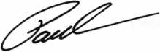

Paul M. Kanitra

LEGISLATIVE  
ACTION NETWORK

You’re a professional locksmith,  
not a professional lobbyist.

You can’t be on the steps of every state capitol and walking the halls of the federal government to protect your profession, but...

WE CAN!

The ALOA Legislative Action Network (LAN) needs Your support for the Voice of Our Profession.

The ALOA Legislative Action Network is constantly working to influence legislation that’s important to the locksmithing profession. We are working in your best interests to promote legislation that will have a posi­tive impact on our proud profession; while preventing or limiting legislative efforts that are harmful. To con­tinue, we need your help to ensure the success of our legislative program for 2004!

If you contribute $25-$99.99 to the Legislative Action Fund, you automatically become a member of the Legislative Action Network (LAN). The LAN is an important tool in raising the standards of our profes­sion through the legislative process by making sure that locksmiths have the final say in how our industry will be run. As a LAN member, you will receive:

* The Legislative Action Network Update alerting you to important legislation in your state and around the country.
* Networking opportunities with ALOA members who share the belief that legislative involvement is important to the effectiveness of our association.
* A listing of your state representatives and senators including capital and district addresses, and phone and fax numbers on both hard copy and disk.
* A comprehensive guide to lobbying in your state capital, so you can be the "voice of ALOA" to legis­lators.
* LAN stationary and envelopes for sending official letters to legislators, lobbying on ALOA’s behalf.
* A lapel pin designating you as a special ALOA LAN member,
* Recognition in Keynotes magazine.
* An invitation to an exclusive reception at the annual ALOA convention for LAN members.

When you donate $100 or more, you become part of the heart of the legislative program through LAN membership and receive the following:

* A reserved place of distinction on the special LAN Council
* Discounts on ALOA bookstore items and a 10 % rebate on all ACE classes.
* Complimentary Legislative Convention merchan­dise.
* It’s easy to do Your part.. .just join TODAY!!

NOTE: Contributions or gifts to the Associated Locksmiths of America, Inc. are not tax deductible as charitable contributions or as business expenses under IRC-162(e).

Keynotes • March 2005

**41**

Buyer's Marketplace

IN-STOCK...MORE SAFES

***FREE Freight Program***

***(30 States)***

AMSEC RreKing **BaM** HAYMAN MEILINK yiCTOK

**TURD lO**

**WHOLESALE SERVICE**

800-848-9790

.25+ Function

Multi-Tool

**—** Lifetime Warranty **—**

FOR LOCKSMITHS ONLY

* 25 Functions
* Services Schlage, Baldwin,

Corbin/Russwin, Lori,

Adams Rite, Master

padlocks, Medeco, Arrow,

Jackson crossbars and

many more!

Call Toll Free...

888-634-LOCK

[www.lockmantools.com](http://www.lockmantools.com)



**SAFE CORPORATION**

MANUFACTURES OF QUALITY DEPOSITORY SAFES AND CHESTS

DISTRIBUTING FROM WAREHOUSES IN • LOS *ANGLES, CA*

* CHICAGO, IL
* GLASSBORO, NJ

A & B is now a stocking distributor

for Mutual Safes

featuring

■

AB-4-30-3S

Chose from over 75 models in stock

I

AB-9-2

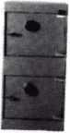

WS 10-2

We ship your order within

24 hours

See us

*at* [www.a-bsafecorp.com](http://www.a-bsafecorp.com)

800-253-1267

Fax 856-863-1208

CALL FOR YOUR CATALOG TODAY

Keynotes • March 2005

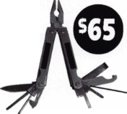

call me.

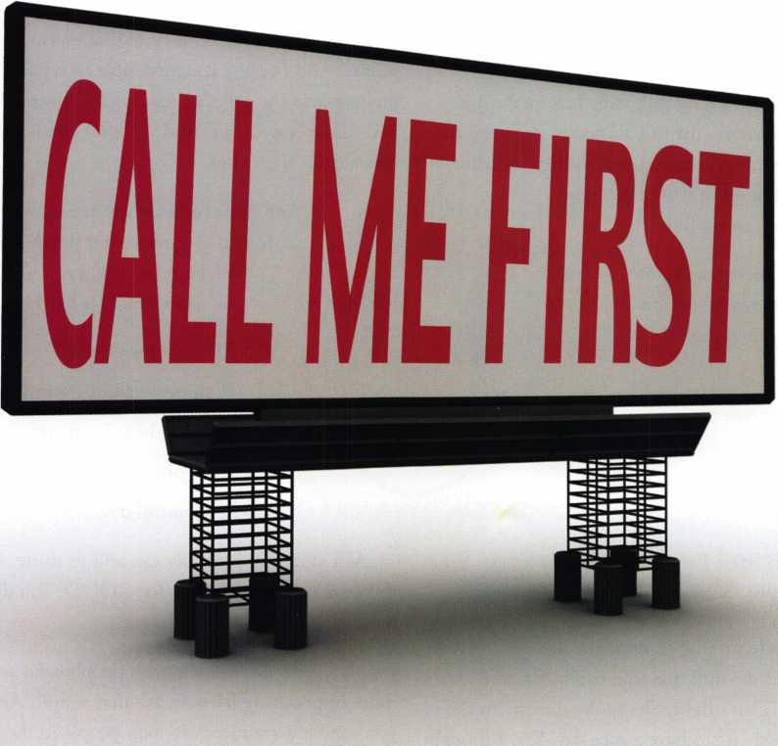

which one catches your attention?

Bigger is sometimes better. And when someone is in need of your services, you want to take every opportunity to make your name prominent in the minds of searching consumers.

Introducing a new advertising solution from ALOA. At our new public locksmith search site, findalocksmith.com, you can now purchase an ad for your business that will shine brightly on the results page whenever someone searches for a locksmith in your zip code. The initial cost is only $30.00, and each additional zip code you add is only $5 extra. Don't miss this great opportunity!

Call Kim Hammond at 817-645-6778 for details.

Spaces for each zip code are limited. Call to reserve yours now!

Have a Nice Day

by Nancy Friedman, Telephone Doctor

How many times a day do you think that phrase is said to someone? Or just how many times has that phrase been said to you in one day? I’m often asked if "Have a nice day" can be said too many times?

All Telephone Doctor training programs help make it a great day. Ask to preview Curt to Courteous, designed to help call centers communicate better with their customers. Call 314-29IT012 or go to [www.telephone- doctor.com](http://www.telephone-doctor.com) and preview on line.

mean so much more. And oh, by the way, "Have a nice day" doesn’t even count, unless you’re smiling.

And then there’s the phone call that ends with the same phrase. And because it’s impossible to say that phrase while looking into the caller’s eyes directly, it needs to be said with more conviction. And yes, that good, old smile still needs to be there, too.

l »

The answer: Yes, I guess it could if you’re saying it to the same person over and over. That might get annoying.

However, for the average person, hearing a genuine "Have a nice day" can be a good thing to hear - "genuine" being the key word.

Example: The other day I was in a video store (as always, we don’t name names) and rented several videos. The person, who was waiting on me, did so in complete silence. Complete silence that is, until she handed me my change. Know what she did? She told the cash register to "Have a nice day." That’s right. She spoke directly to the cash register and told "it" to have a nice day. Yea, I thought she was pretty strange too.

And not long before that, I had a young man at another store (yes, I do shop a lot!) tell the floor to have a nice day.

And again, more recently when I was at a fast food chain - the lady who handed me the meal looked off in space - and told someone out there to "Have a nice day."

Now, some can profess that they were doing the right thing. Almost. Sure the words were there, but the meaning and sincerity sure wasn’t. If you’re telling the cash register and floor to have a nice day, you’re really not doing any good. Try looking in the customer’s eyes and say it. It’ll

And don’t forget, there are so many other ways to end a conversation besides "Have a nice day." Here are just a few. (And I’m betting you can think of a batch of your own.)



"Thanks for calling."

"I enjoyed talking with you."

"Good to hear from you."

"Enjoy your day."

Have a beautiful day."

As I said, you probably can add to those. Remember, there are lots of synonyms for GOOD. You don’t need to be stuck on that one word.

People like to do business with people who are nice and more importantly friendly. It’s that simple. And the way you can be extra nice is to look people in the eye when you’re talking with them. SMILE, and make it meaningful. On the phone, give the caller your full attention. Even though you’ve heard the problem or the question 800 times, that one person is most probably going through it for the first time.

Enjoy much health & happiness this year, And MAKE IT A GREAT DAY!!!

All Telephone Doctor training programs help make it a great day. Ask to preview Curt to Courteous, designed to help call centers communicate better with their customers. Call 314-291 ■ 1012 or go to [www.telephonedoctor.com](http://www.telephonedoctor.com) and preview on line.

Keynotes • March 2005

Email: [glmperry@iwuisp.com](mailto:glmperry@iwuisp.com) for unlock code Greg perry 2003



SafeData

Greg Perry, CIVIL, CPS

Open up your library! SafeData allows you to find the information you've  
invested in, fast.This one program has over 8500 listings of magazine, books,  
ClearStar Security Network posts and my personal library. Each listing includes not  
only the book or magazine, the issue, the title, the author and the page, but it also  
lists the lock and the hand of the lock (when available). SafeData lists patent dates  
and other trivia that may help in identifying a container or lock.

SafeData also has picture folders representing over 90 different manufactures of  
safes and locks with over a thousand pictures. Some models include a text file giv-  
ing general information on size and relock locations. Plus you can add your own  
information and update it yourself or purchase the annual updates.

SafeData is available exclusively from ALOA. Normal price for this CD is $249.95.  
Price includes two installs! Put it on your desktop and your laptop.

Special Introductory offer

includes your first update!

$199.95

To order contact ALOA (800) 532-2562

**SearchAlert**

**/^colors that/**

*'ufap to Ip*

Prevents

Surreptitious Entry  
at Airports.

Know when your bag  
has been searched  
by a TSA agent  
or violated by

*ako amlabk:*

an unknown person.

Black Fire Engine Red

Pewter Purple Grape

Bright Nickel Construction Orange

Brass Plated Cobalt Blue

Hot Pink



Security Products

301 West Hintz Road Wheeling, IL 60090 800.733.8588 Fax: 847.537.1881 [www.cclsecurity.com](http://www.cclsecurity.com)

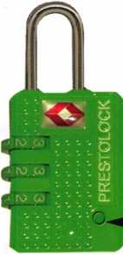

**TRAVEL SENTRY**

CERTIFIED

Recognized by the TSA

Security Window

I lock has been opened

jo lock not opened

